**Agile:**

Agile is a mindset. Mindset of Adaptivity. Agile is a value system guided by a mindset. Scrum and Kanban are frameworks to attain Agility. Agility' is our ability to respond to change. An **agile mindset** is the set of attitudes supporting an agile working environment. These include respect, collaboration, improvement and learning cycles, pride in ownership, focus on delivering value, and the ability to adapt to change.

**How fast we are delivering high valued items. Accelerating delivery by eliminating wastage.**

**Uses:** Incremental Delivery, Features can evolve over time, Risks are mitigating early, Revenues (ROI) are generated early, Reduced and Visualized WIP.

Agile is a development methodology based on iterative and incremental approach. Agile software development refers to a group of software development methodologies based on iterative development, where requirements and solutions evolve through collaboration between self-organizing cross-functional teams. Agile is not a methodology or framework by itself. Agile is a value system guided by a mindset. Many methodologies and frameworks for iterative and incremental software development fall under the Agile umbrella. Each method or framework is unique in its specific approach to Agile. Yet, they all share a common vision of the 4 core values and 12 principles that guide the Agile mindset.

Agile is a mindset defined by 4 values, guided by 12 principles, and manifested through many different practices.

**Agile Values:** The four core values of Agile software development as stated by the Agile Manifesto are,

1. Individuals and interactions over processes and tools.
2. Working software over comprehensive documentation.
3. Customer collaboration over contract negotiation.
4. Responding to change over following a plan.

**Agile Principles:**

1. Satisfying customers through early and continuous delivery of valuable work.
2. Welcoming changing requirements, even late in a project.
3. Deliver Frequently
4. Work Together
5. Build Projects
6. Face-To-Face Time
7. Measure of Progress
8. Sustainable Development
9. Continuous Attention
10. Keep it Simple
11. Organized Teams
12. Reflect for Effectiveness

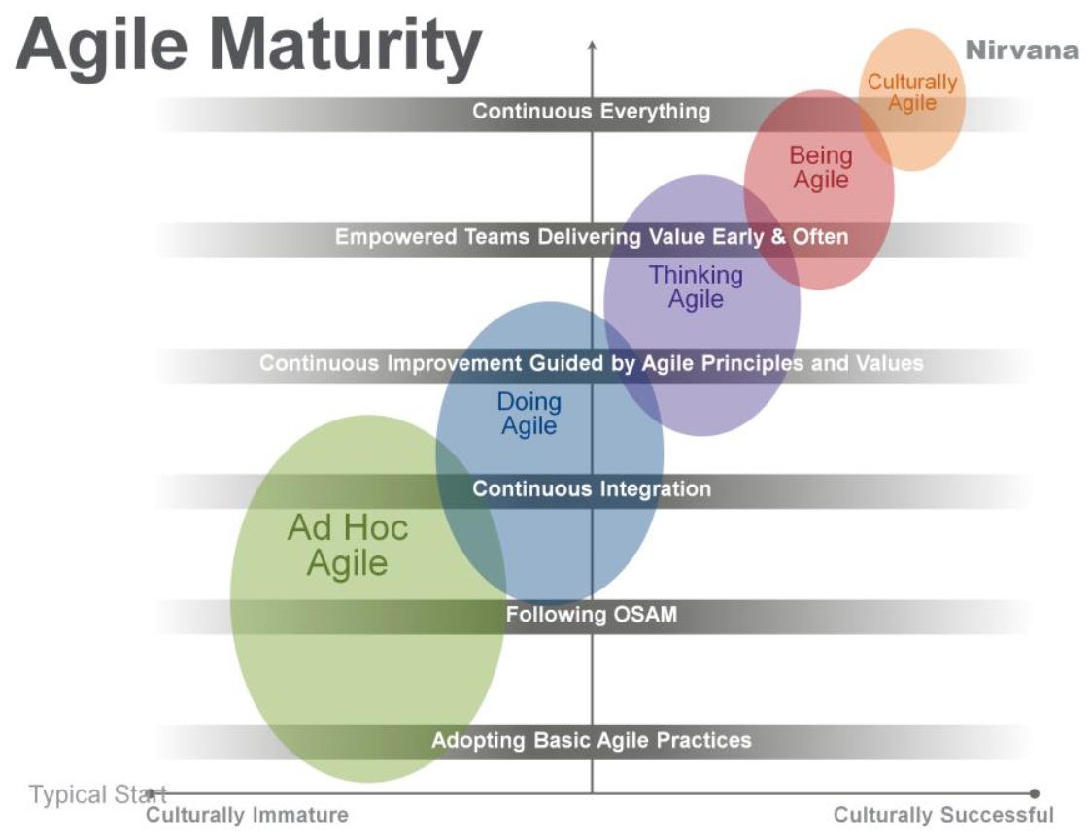

**Being Agile:**

Being **Agile** does **mean** working in a lightweight, highly responsive way so that you deliver your product or services in the way the customer wants and at that time the customer needs them. **Being agile** focuses on team and leadership mindset, as well as behaviors and adoption.

**Doing agile** focuses on tactics, ceremonies and techniques. Teams that stay **true** to the spirit of **Agile** are self-organizing.

**Scrum: Scrum is an agile process that allows self-organizing teams to focus on delivering the highest business value in the shortest time.** Scrum is a framework for project management that emphasizes teamwork, accountability and iterative progress toward a well-defined goal. When it comes to product development, Scrum roles include product owner, Scrum master and Scrum development team. Empirical process control based.

Empiricism: Knowledge comes from experience and making decisions based on what is known. Working in a fact-based, experience-based, and evidence-based manner. Scrum implements an empirical process where progress is based on observations of reality, not fictitious plans.

**aScrum 3 pillars:** Transparency, Inspect and Adapt

**Transparency:** Significant aspects of the process must be visible to those responsible for the outcome. Transparency requires those aspects be defined by a common standard so observers share a common understanding of what is being seen. For example: • A common language referring to the process must be shared by all participants; and, • Those performing the work and those accepting the work product must share a common definition of “Done”. 4

**Inspection:** Scrum users must frequently inspect Scrum artifacts and progress toward a Sprint Goal to detect undesirable variances. Their inspection should not be so frequent that inspection gets in the way of the work. Inspections are most beneficial when diligently performed by skilled inspectors at the point of work.

**Adaptation:** If an inspector determines that one or more aspects of a process deviate outside acceptable limits, and that the resulting product will be unacceptable, the process or the material being processed must be adjusted. An adjustment must be made as soon as possible to minimize further deviation.

**Scrum Values:**

* Focus: Everyone focuses on the work of the Sprint and the goals of the Scrum Team.
* Courage: Scrum Team members have courage to do the right thing and work on tough problems.
* Openness: The Scrum Team and its stakeholders agree to be open about all the work and the challenges with performing the work.
* Commitment.
* Respect.

**Scrum Principles:**

* **Empirical Process Control**—This principle emphasizes the core philosophy of Scrum based on the three main ideas of transparency, inspection, and adaptation.
* **Self-organization**—This principle focuses on today’s workers, who deliver significantly greater value when self-organized and this results in better team buy-in and shared ownership; and an innovative and creative environment which is more conducive for growth.
* **Collaboration**—This principle focuses on the three core dimensions related to collaborative work: awareness, articulation, and appropriation. It also advocates project management as a shared value-creation process with teams working and interacting together to deliver the greatest value.
* **Value-based Prioritization**—This principle highlights the focus of Scrum to deliver maximum business value, from early in the project and continuing throughout.
* **Time-boxing**—This principle describes how time is considered a limiting constraint in Scrum and used to help effectively manage project planning and execution. Time-boxed elements in Scrum include Sprints, Daily Standup Meetings, Sprint Planning Meetings, and Sprint Review Meetings.
* **Iterative Development**—This principle defines iterative development and emphasizes how to better manage changes and build products that satisfy customer needs. It also delineates the Product Owner’s and organization’s responsibilities related to iterative development.

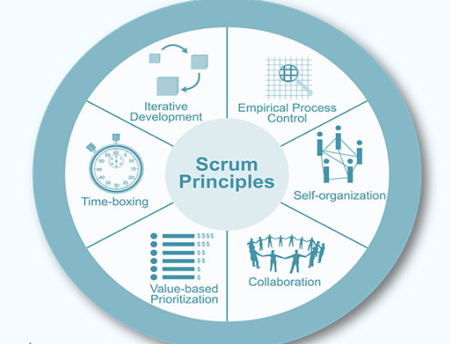

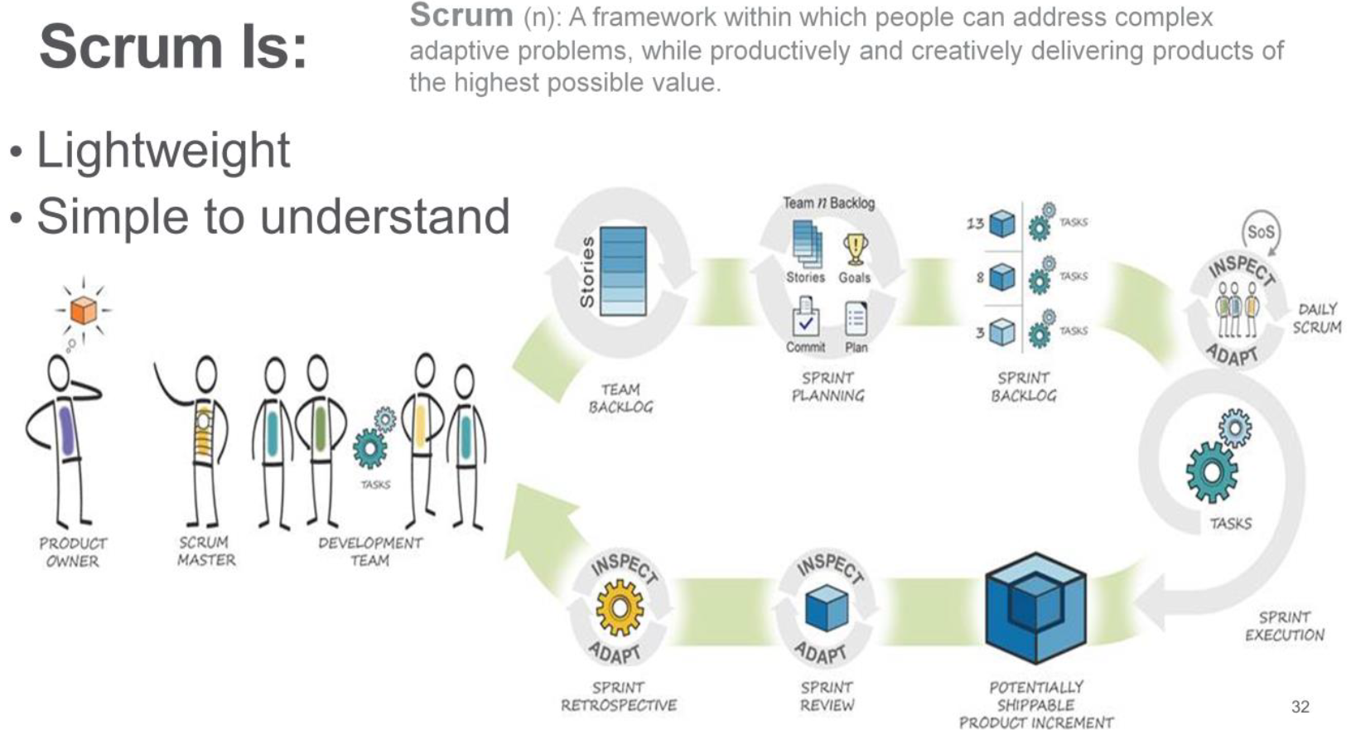

The Scrum Master is a person, who ensures that scrum principles are being followed.

SM is servant leadership who lays a path towards sustainable development.

**The SM role is to help others become high-performing as a team. A great SM helps change the culture so scrum teams can thrive/flourish/bloom.**

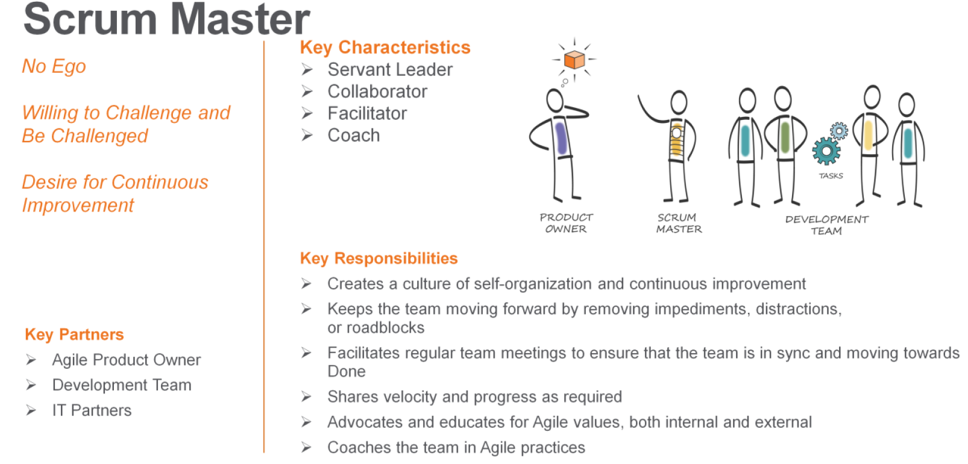

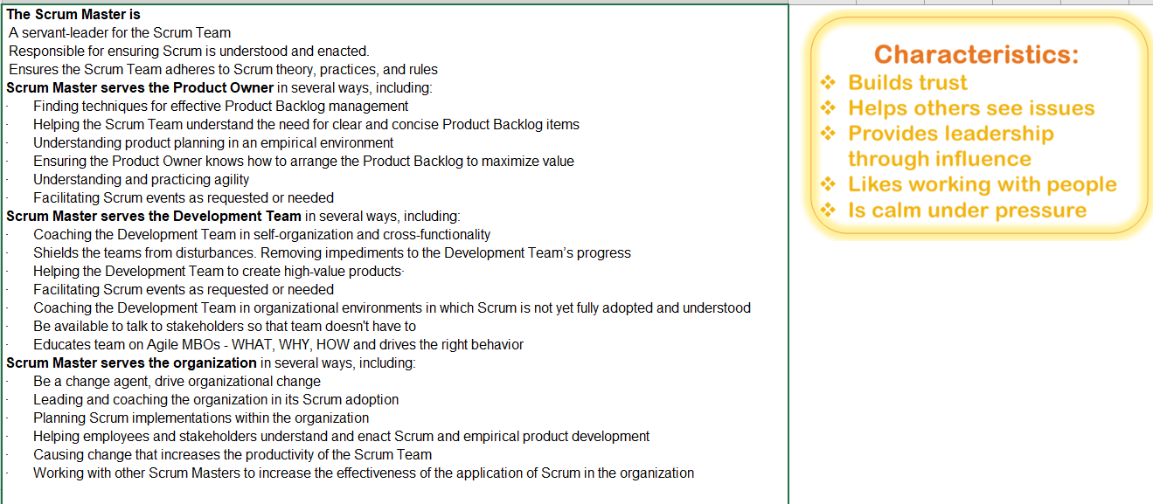

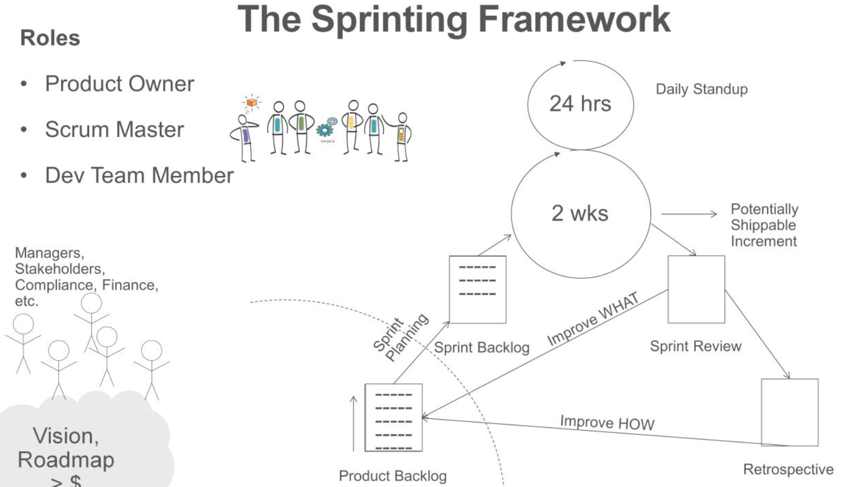

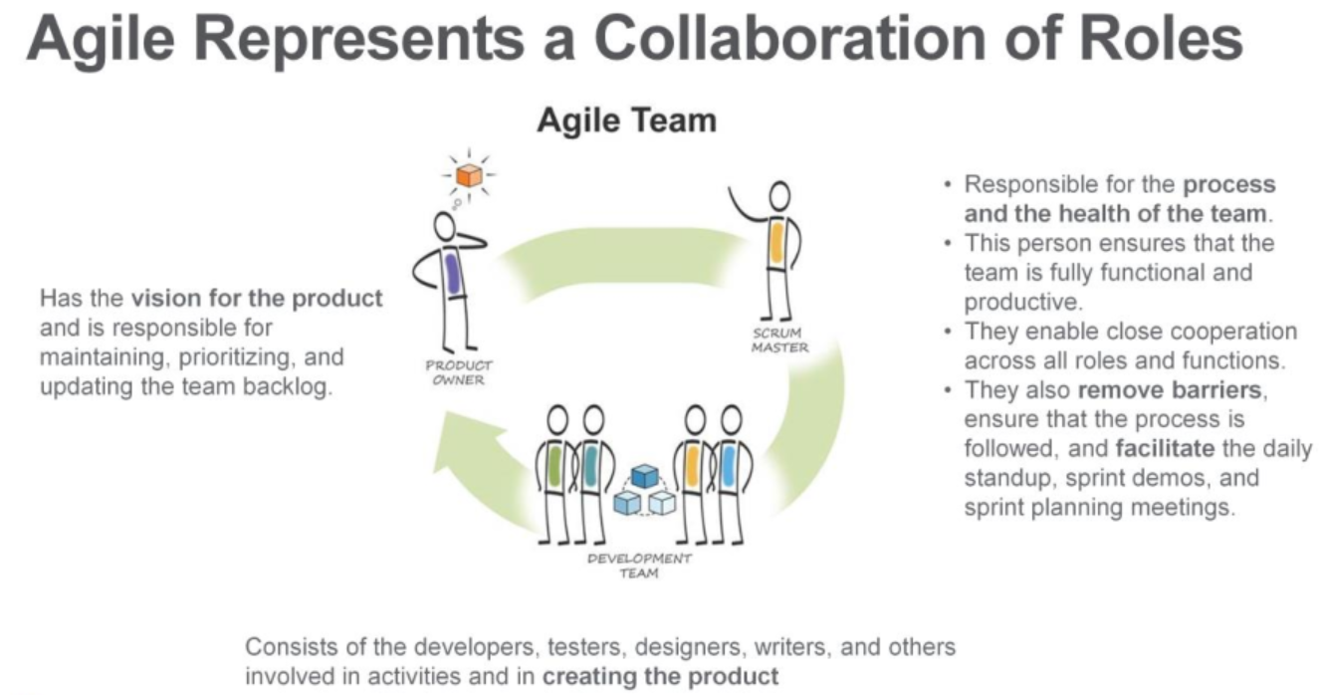

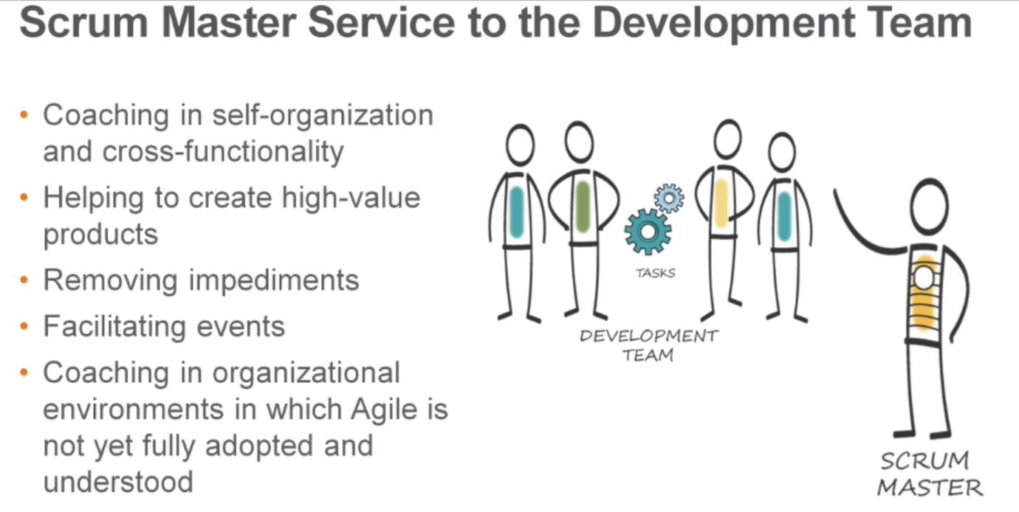

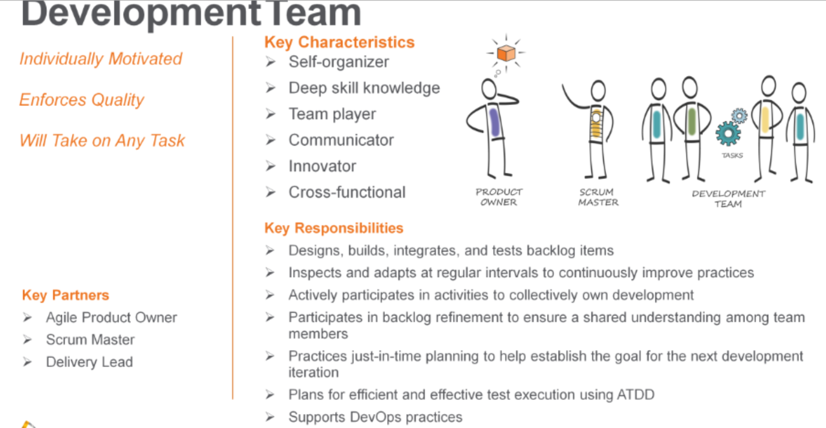

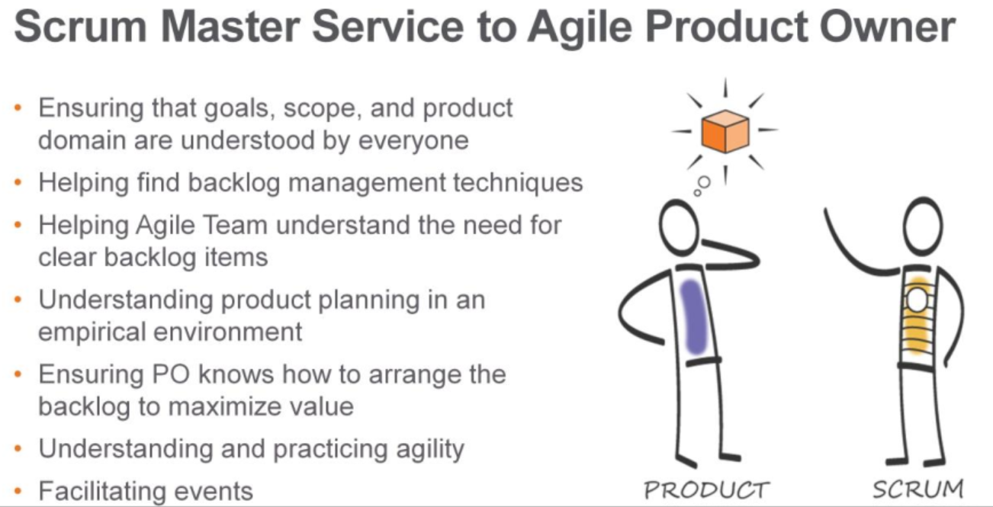

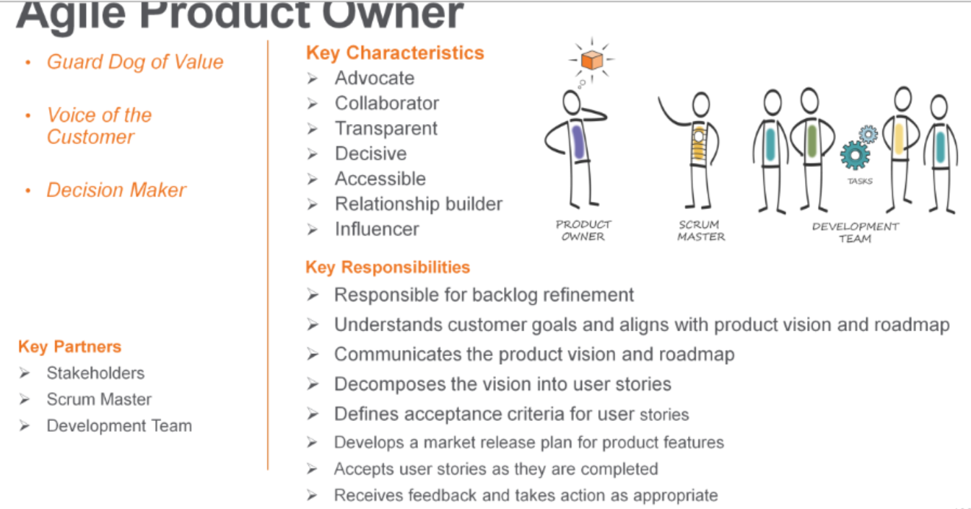

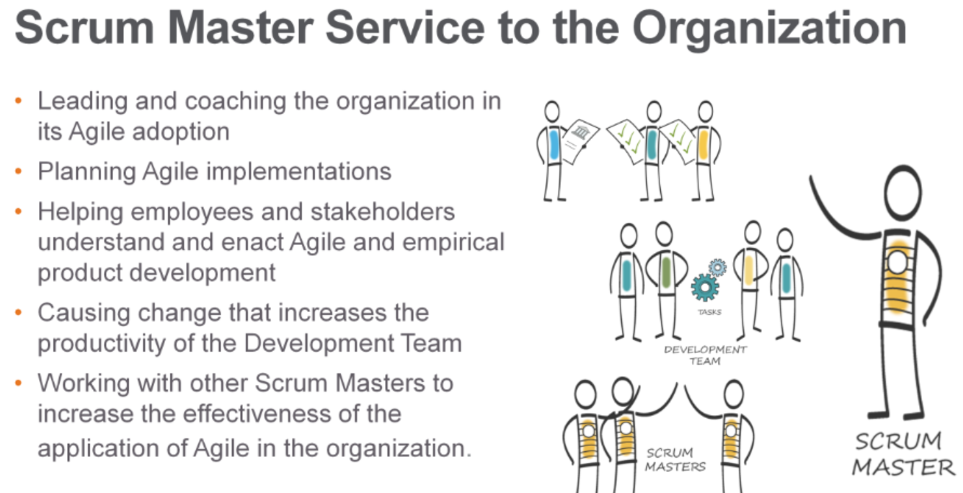

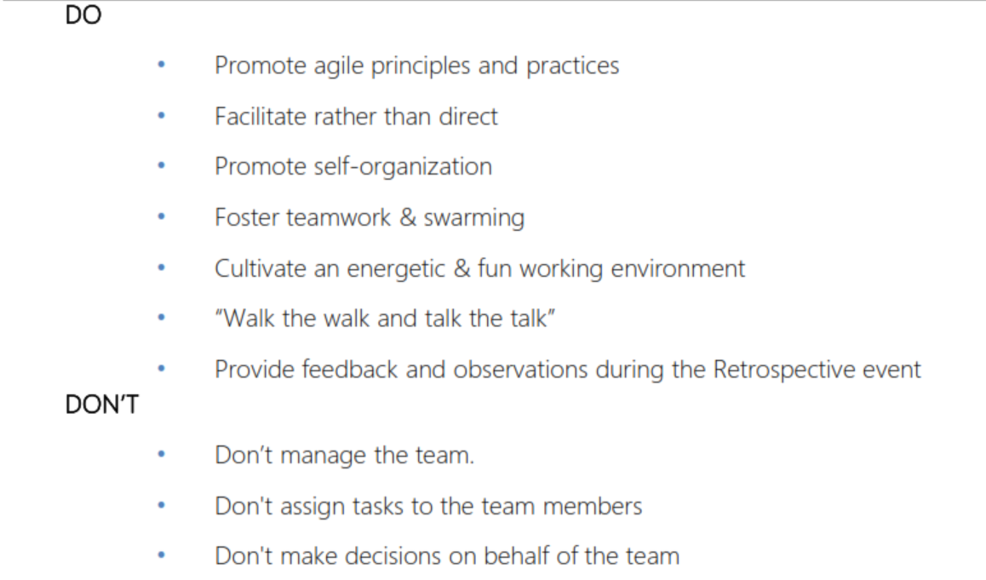

**]**

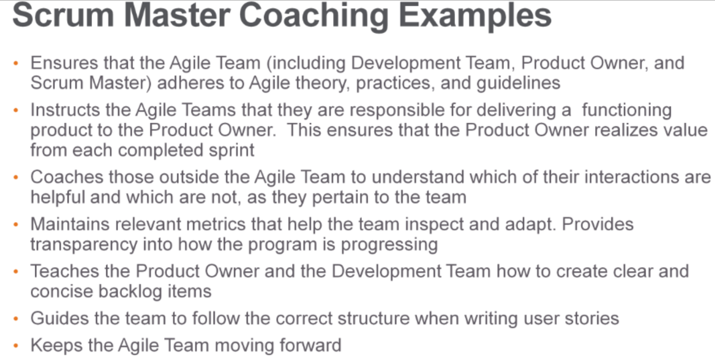

1. **Daily Scrum Uses?**

**Purpose** and Outcome. The **purpose** of the **Daily Scrum** is to inspect and synchronize the team's progress towards the Sprint **Goal**, discuss if anything impedes the team and re-plan the team's work to achieve the Sprint **Goal**.

1. **What are the steps you follow if you get 5 members to start a new Scrum team?**

Identifying Trainings Needs. Including management, dev team.

Roles (sm,po,dev team)

Sprint1. Vision, roadmap, agile team charter (working agreements, DOD, note members & roles, or whatever rules that everyone adhere)

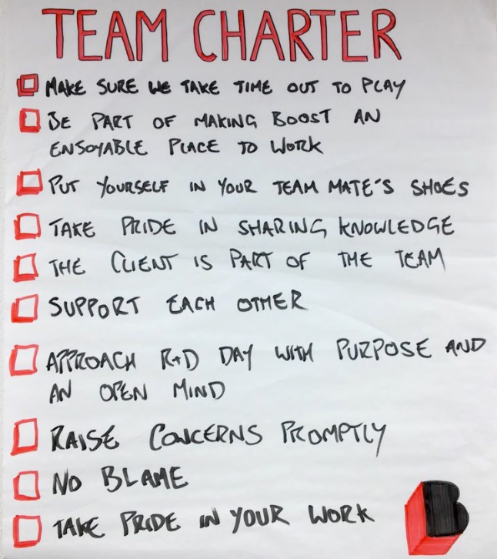

1. **A Scrum team has the right amount of Technical and Process expertise. However, they are expecting a SM who can get the right “CULTURE” into the team thus enhancing Agility. As a SM, how do you incorporate the culture?**

By changing the work habits …How to change the work habits? – By bringing the policies and revisit them time-to-time and adapt accordingly – “Inspect and Adapt” is the key.

1. **You already performed Scrum training for stakeholders. After an initial phase of trying to apply the concepts, when first obstacles/hurdles are encountered, you see that these colleagues build serious resistance in continuing with Scrum adoption. What is your strategy/experience to handle such situations?**

Ask them what is the problem in implementing Scrum. Retrospect – facilitate and collect the feedback. Understand their problems, concerns and address them. Tell them that everything is available in Scrum framework. Ask them for solutions. Inspect and Adapt for some time.

1. **A team member not performing in a team, how will you deal this as a Scrum Master?**

Take it in Retrospective: Did the team speak in Retrospective; did they have courage to speak up in Retrospective? If NOT, as a SM, do you have the courage to provoke this discussion in Retrospective? Like asking - Guys, do you have any concerns in the team, are everybody working together? Have powerful questioning to bring the reality which triggers the team to open up.

1. **A team among 5 scrum teams is NOT performing (neither supporting other teams not respecting scrum values). All these 5 teams are part of a single ART, how will you deal this as a Scrum Master?**

If you are a SM, you don’t have anything to do here; however, you can bring this up in SoS meeting.

If you are an RTE, work with stakeholders and SM of that particular team. If SM is inefficient these things will prevail. Take action on SM, fix him, which in turn fixes the team. You can also take this up in I/A workshop.

1. **You have been just hired as a new Scrum Master. The team you’re going to work with doesn’t have any experience in Agile and is very skeptic about Scrum. They want to focus only on coding and don’t want to track their progress or attend any meetings. How do you influence and motivate them to use Scrum?**

Talk about the value of Scrum; Tell the purpose of Scrum. If SM can make them to understand the power of Scrum, then it will give results in sometime.

1. **Product Owner doesn’t have any experience in Agile methodologies. He used to manage Waterfall projects. He doesn’t want to participate actively in Scrum events like Sprint Planning, Sprint Review and be available for Dev Team during Sprints. What would you do to make sure the Scrum process is being applied?**

Have a meeting with PO and check his problem and why he is not available – “what is the issue, where I can help”. If he is not happy about framework, show him all the levers available in the framework. Explain the PO about the worth if his position, make him realize the importance of it, and then help in understanding through Business Value, Metrics, etc. If needed, extend your help in PO in coaching and training aspects.

Talk about the value of Scrum; Tell the purpose of Scrum. If SM can make them to understand the power of Scrum, then it will give results in sometime.

PO is not capable? Ans:

1. **The project is delayed three months/has lots of dependencies/based on old technology. Do you find this appealing/challenging for you? Have you worked in the similar situation?**

- YES – Start thinking in Agile way – Dependencies could have been bubbled earlier by collaboration, and prediction could have been better. Bring Agility…!!

1. **What is Sprint Hardening? Why & when it is done?**

There is no such thing like Hardening Sprint / Sprint 0 / Release Sprint, etc. There is no Business value expected by performing these sprints. Some people/organizations do the above to handle any undone work which is leftover in previous sprints, perform regression testing, perform integration or merging the code before a release, etc.

1. **PO and Dev Team yet to come up with stories in “ready” state. We have nothing to take up in Sprint Planning. As a SM, what will you do in this regard?**

Figure out with what you can start and let the ball rolling – “JIT / Bare minimal”

1. **Development Team has “no work” as PO has no defined forecast on the day of Sprint Planning. As a SM, what will you do?**

* Provide opportunity to learn and strengthen engineering practices.
* Let them innovative and creative – provide them some free space. Future could be better.
* Ask them to figure out the opportunities – this will give them empowerment and opportunity.

1. **What factors will help deciding the sprint duration?**

Establishing Sprint length depends on the following factors:

1. The risk of being disconnected from the stakeholders
2. The ability to go to market with a product release
3. The level of uncertainty over the technology to be used
4. **What factors will help Product Owner to make a decision to release the increment?**

* Market readiness – consider the conditions like: Is the market ready to accept the changes?
* Customer – How much Business Value is being incurred by releasing the Increment into Production environment.

1. **What if your Definition of Done enhanced after few Sprints?**

As Scrum Teams mature, it is expected that their definition on “Done” will expand/enhanced to include more stringent criteria for higher quality. (Eg: 1st sprint’s DOD is different from 10th sprint’s DOD).

Enhancing the DoD will improve the Quality of the Product Increment.

1. **How do you ensure that the Scrum team has access to the stakeholders?**

TRANSPARENCY (Refer: Visible Information Radiators) is one of the key element that SM need to maintain. And, SM should enable direct communication/coordination between Scrum team and business stakeholders and shouldn’t act like a bridge between them.

1. **How do you manage sick leaves in a sprint to make sure you still achieve the sprint goal?**

A Scrum Master loads the team Capacity (how many available hours in Sprint) before/during the Sprint Planning event. SM need to ensure the team is not loaded beyond 80% and keep the remaining 20% as buffer so that we can accommodate any unforeseen instances like, unplanned/sick leaves, scope changes, etc. (**Contingency Plan**).

1. **How can you keep motivating your team?**

TRUST and RESPECT are the key elements that a Scrum Master need to ensure to bring something effective and outcome oriented.

1. **How do you track Metrics in your Project?**

Nothing specific in tracking the metrics. If we maintain clean data in our project management tool (Rally, Jira), our metrics will be accurate. There are some instances where the senior management requests for the metrics. We have few popular metrics like Feature Cycle Time (time-to-build, time-to-value), Productivity (MBO’s/ Management by objectives (MBO) is a strategic management model that aims to improve the performance of an organization by clearly defining objectives that are agreed to by both management and employees. we can calculate Productivity based on the Size/effort(Size is no of Story points)), Defects, Agile Maturity Assessment report (It will be divided into categories like Roles, Artifacts, Rules and Events, also Plan and all) which we track and share.

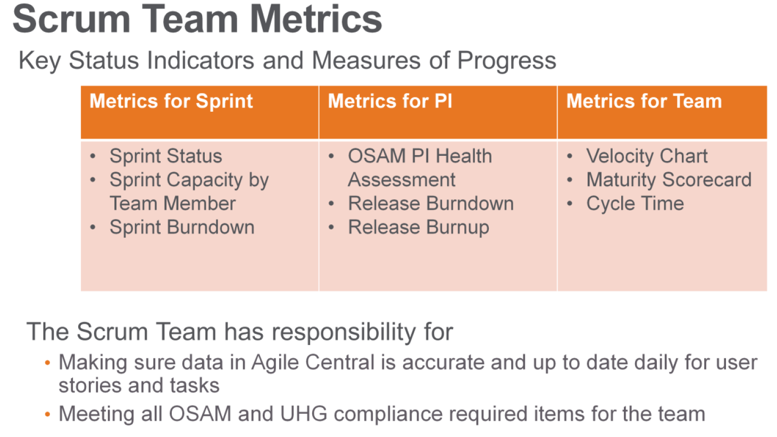

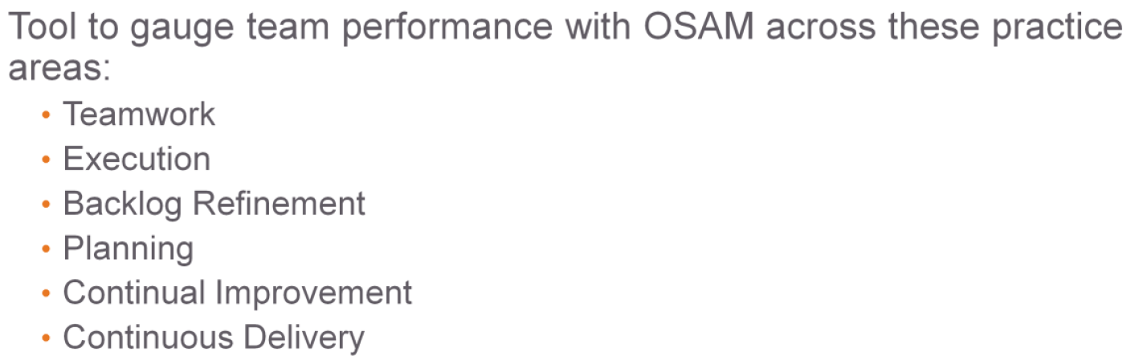

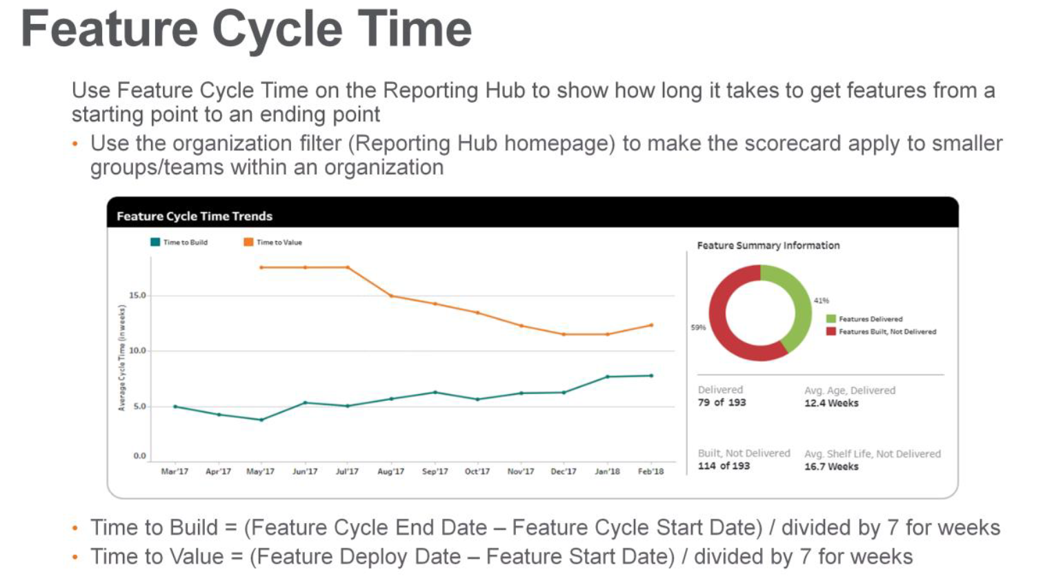

1. **Do you use any Technique in Sprint Retrospective & How?**

There are few of the techniques to make our Retrospectives effective and efficient. They are:

* What went well? What didn’t go well? Any improvements.
* Start-Stop-Continue
* Speedboat
* DAKI (Drop Add Keep Improve)

1. **What is Difference between BDD and ATDD & Process do you follow in Implementing ATDD?**

Differences between TDD BDD and ATDD:

* BDD focuses on the behavioral aspect of the system rather unlike the TDD focuses on the implementation aspect of the system.
* ATDD focuses on capturing requirements in acceptance tests and uses them to drive the development. It seems like ATDD focuses on external quality of the software (does the system do what it is required to do?).
* ATDD leans towards the developer-focused side of things like [Unit]TDD does, the BDD is where the step of making it more customer-focused comes in. This allows much easier collaboration with non-techie stakeholders, than TDD.
* TDD allows a good and robust design, still, your tests can be very far away of the user requirements
* BDD is a way to ensure consistency between user requirements and the developer tests
* TDD is just the process of testing code before writing it. DDD is the process of being informed about the Domain before each cycle of touching code. BDD is an implementation of TDD which brings in some aspects of DDD.

In **TDD** (Test Driven Development), the test is written to check the implementation of functionality, but as the code evolves, tests can give false results. **BDD** (Behavior Driven Development) is also a test-first approach but differs by testing the actual behavior of the system from the end users perspective.

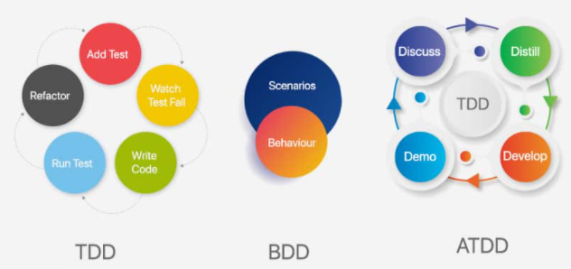

1. **Have you collaborated with different teams in delivering a product to a value stream?**

Yes, depending upon the application complexity we do have upstream/downstream applications where our application interacts through web services. We do foresee some challenges with respect to the outage, server issues (infrastructure), etc.

1. **What are the Scrum Values you bring in to your Team?**

Courage, Commitment, Focus, Openness, Respect are the Scrum values that needs to be exhibited by the Scrum team and SM should ensure they are understood and enacted.

1. **What if as a SM you are not able to attend a daily standup meeting, so do you think SM should happen/not happen/team should postpone so that you can attend.**

Scrum Master is optional to the Daily Scrum event. However, he/she need to ensure that the event is happening every day without fail, and within the timebox.

1. **Is BA, SA Part of the Scrum Team? If Yes, do they need to be 100% dedicated with the Team as per Scrum Framework?**

Yes, if they are contributing to Product Increment, they can be part of the Development Team. Scrum doesn’t have any mandates over dedicated or shared roles. However, the outcomes are affected by availability.

1. **What is Bill Wake’s INVEST?**

In order for a user story to be clear and unambiguous, it should satisfy INVEST principle as described below table. Whenever you are writing a story, ensure that it satisfies the “INVEST” principle. If it is not satisfying, then try to split as per the guidelines provided above so that it will meet “INVEST” principle. It is essential to write user stories, which are small and independent enough to be worked on in each sprint.

|  |  |
| --- | --- |
| **Independent** | User Story should be Independent. So that they will not overlap, such that can be implemented in any order.  The user story should be self-contained; in a way that there is no inherent dependency on another user-story. Split large stories into smaller ones will reduce the dependency to maximum extent. Stories should be independent enough so that the team doesn’t have to pull in many other stories along with that story. |
| **Negotiable**  *(w.r.t Scope)* | User Story should be Negotiable. The team should able to negotiate with Product Owner or end user.  User-stories, up until they are part of iteration, can always be changed and rewritten. Discuss more & identify what is really needed because user-story is not written contract, they are instrument for having conversation. The goal of user-story is not requirement documentation, but, creates a small instrument which facilitate discovery of requirement through collaboration. Team should be able to negotiate stories in and out of a sprint. This way the team can maximize the value. |
| **Valuable** | User-story should provide Business value which can be tangible/intangible. Valuable to the customer directly or indirectly. A technical story may not add a direct value to the customer. The user story should be of appropriate size and content, hence they can provide value to business. |
| **Estimable** | User Story should be Estimable. If the user story is of right size than it can be accurately estimable and plan accordingly. Team should be able to estimate the size of the stories (less ambiguity). This requires clarity on detail and the stories are independent. |
| **Sized Appropriately**  **/ Small** | User story should be small. Being small makes easier to work with. User stories should not be so big as to become impossible to plan/task/prioritize with a certain level of certainty. Higher order stories are smaller in size such that they could be completed in a sprint. |
| **Testable** | User story should be testable. All user stories must be tested and tested early. The user story or its related description must provide the necessary information to make test development possible. A story should cover one piece of functionality that could be tested in isolation. User-story should have acceptance criteria attached to the story. If “T” is missing, then we end with non-working software and lead to re-work. |

1. **What is DEEP Analysis?**

A Product Backlog is best described as “DEEP”. Product Backlog should be…

* 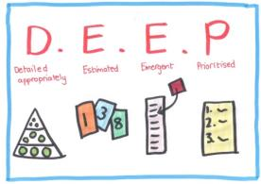**Detailed Appropriately:** (JIT - just in time, don’t give too much info) Higher order items are more detailed and well understood compared to lower order items. User stories on the product backlog that will be done soon need to be sufficiently well understood that they can be completed in the coming sprint. Stories that m not be developed for a while should be described with less detail.
* **Emergent:** (evolving, progressively elaborated) Product backlog is a living artifact. A product backlog is not static. It is always updated for details, estimates and order. The life of the product backlog is same as life of the product itself. Product Backlog is progressively elaborated – requirements are not detailed enough from beginning (just one liner / pointer). It will change over time. As more is learned, user stories on the product backlog will be added, removed, or reprioritized.
* **Estimated:** Product backlog items are estimated in relative sizes by development team. Product owner orders the items based on value and the cost. The Product Backlog is more than a list of all work to be done; it is also a useful planning tool. Because items further down the backlog are not as well understood (yet), the estimates associated with them will be less precise than estimates given items at the top.
* **Prioritized:** Product backlog items are ordered based on the priority. The order is force ranking (1, 2, 3...) so that there are no competing priorities. The product backlog should be sorted with the most valuable items at the top and the least valuable at the bottom. By always working in priority order, the team is able to maximize the value of the product or system being developed.

1. **Explain PDCA / Deming Cycle?**

Agile teams execute a full plan-do-check-adjust (PDCA) cycle as quickly as possible. The PDCA learning cycle represents the following iteration events:

* **Plan** –**Iteration Planning** is the plan step
* **Do** – **Iteration Execution** is the do step
* **Check** – **Iteration Review** is the check step
* **Adjust** – **Iteration Retrospective** is the adjust step

1. **Who updates the Release Burn down?**

Product Owner

1. **Who updates the Sprint Burn down?**Development Team
2. **What is Backlog health? Who manages it?**

Product Owner owns, creates and maintains the Product Backlog. PO is responsible for the Product Backlog, including its content, availability, and ordering. PO updates the backlog based on the below:

* Market conditions
* Technical dependencies
* Product Architecture
* Regulatory Act
* Lessons learned from the completed sprints

PO maintains the health of the Product Backlog by making sure:

* + To prioritize based on high value
  + To assess the value of each item
  + To provide acceptance tests

1. **Explain your daily activities you do as a SM [OR] What are the day-to-day activities of a Scrum Master?**
2. First thing is to make myself ready for Daily Scrum. Look at the impediment list and check if it is worked upon and removed.
3. Facilitate daily scrum.
4. Discuss with Development team in case needed
5. Discuss with PO in case required.
6. Continue Working on impediments if any.
7. As part of CoP (Community of Practitioner) discuss with other SM in organization about any topic which help team perform well.
8. Explore on KPI (Key Performance Indicator) which can help in reporting to management.
9. Continuous learning is essential for SM.

Came across one blog in Scrum.org

<https://www.scrum.org/resources/blog/day-life-scrum-master>

1. **Can PO work as a Development Team member on Scrum Team?**

YES. Assuming PO as SME, he can be part of Development Team as Business Analyst, etc. If he is good at coding and has good functional aspect, he can act as developer also.

If PO feels like “As a PO, I have the ability to contribute to Done increment” he can be part of the Development Team.

1. **Can SM work as a Development Team member on Scrum Team?**

YES. If the SM has technical aspect and feels he can contribute to DONE Increment, he can be part of Development Team.

1. **Can a same person act as PO and SM?**

No. It creates a conflict of interest between asking “what to do” and asking “how to do”.

1. **Team is unaware of the estimation process. As a SM how do you make sure the team starts estimating?**

Coach the Scrum Team on estimation process. Planning Poker is a popular technique for estimation.

* Planning Poker is an activity development team uses to estimate Relative size of PBIs (Product Backlog Items).
* Planning Poker is a consensus-based approach/technique for estimating, mostly used to estimate effort or relative size of development goals in software development.
* Planning Poker is a way to determine sprint item durations by playing number cards face down the table, instead of speaking them aloud.

Planning Poker - Process:

1. Each estimator is given a deck of cards that contains numbers (0, 1, ½, 2, 3, 5, 8, ?, ∞, coffee cup, etc.). This number series is a modified Fibonacci series. There could be other series some teams use.
   * Fibonacci series (1,2,3,5,8,…) is a non-linear sequence which is a better approach because it reflects the greater uncertainty associated with estimates for larger units of work.
   * Distributed teams can download the planning poker app and provide their respective estimates.
2. Team combs through the product backlog item and picks an item that is well understood and assigns a 2 or 3 to it. This is the reference story for other items. Team might pick another item with is 5 or 8 so that there are two reference stories. Now the team is ready to estimate.
3. Moderator (Product owner) reads out the product backlog item/story. Team asks any questions to understand the item better.
4. All team members pick their number, but keep it face down at this point.
5. All members show the number at once so that there is no influence on each other.
6. Members with who picked low and high numbers give their point of view i.e., Outliners (High and low estimates) are reconciled/clarified.
   * The high estimate is NOT necessarily considered the final estimate because the players with high and low estimates must explain their estimates and then a decision is taken by the players as to the final estimate value.
7. Team estimates again based on new learning from the discussion (No average, No majority. We just try for consensus which give hidden things)
   * If we are conducting a Planning Poker game with our team members to come up with estimates for the stories to be delivered, there is no limit on the number of rounds of Planning Poker should we allow the team for each story., we just play as many rounds until estimates converge.
8. After 2 or 3 rounds, the estimates are expected to converge. Team finally agrees to a number. Else,
   * Choose majority estimate
   * Choose high estimate(s)
   * Average of the estimates
   * Adopt three point (PERT) averaging

*Note: Other estimation techniques like* ***T-shirt sizing****,* ***Affinity Estimation*** *(to estimate large number is items quickly),* ***Triangulation****, etc.*

1. **Can a SM influence a team member during estimation?**

No, estimation is the responsibility of the Development Team, however, Scrum Master can act like catalyst/facilitator to make the Development Team arrive at accurate estimation by triggering discussion around story acceptance criteria, application functionality, uncertainty (hidden elements) of the requirement, complexity of the requirement, etc.

1. **Can a SM influence a team member to do a certain task?**

If a member from Development Team is performing a regular task in every Sprint, SM can definitely use his/her skill to make the respective member to pick diverse tasks to work on. SM can establish a technique like ‘Round Robin’ to make this happen.

1. **Can we estimate Defects? If Yes, can we count the same in Velocity calculation?**

Yes, you can estimate the defect as it has some value. Create a user-story; link the defect to it which gives tractability and accountability. Hence, it will be counted in Velocity also.

1. **Can we estimate Spikes? If Yes, can we count the same in Velocity calculation?**

Yes… Let’s consider a question “Can you do something without Spike?” Definitely NO – Start doing, explore for some time and start estimating as you progress towards. So provide a rough estimate at the beginning and inspect and adapt as you move forward.

1. **How do you trigger Agile transformation into your team/project?**

Agile Transformationshould be principles-based implementation rather than practice-based implementation. Organizations succeed the agile transformation when they approach the change with principle-based perspective (this is internalizing the mindset, values, and principles and then applying and tailoring practices as situation arise). Organizations with only practice-based approach do not know when to adapt/select the appropriate practice – these organizations learn agile practices and apply them without understanding the mindset and principles, limits the ability to select and tailor the practices as needed. If organizations do not correctly apply the practices, the agile transformation can fail.

Important: When you plan to transform to Agile you need to consider few things:

1. Whether you want to go with big-bang approach or team by team
2. Try to do inside out transformation instead of outside in. This means first try to change the culture by appropriately changing the structure. Then try to change the tools and processes.

**We transformed to Agile in the year 2015-16, and then we got trainings from our Agile Coaches and then got certifications done. Then we started coaching our teams towards Agile and giving trainings whenever required.**

1. **How would you coordinate between multiple Scrum Teams?**

Scrum of Scrum (SoS) is an event where multiple Teams collaborate together to discuss on dependencies, risks, assumptions, etc.

1. **Have you worked on scaling scrum? If yes, which framework you have used?**

SAFe, LeSS, Nexus, Scrum at Scale, DAD, and Spotify are the popular Scaling frameworks.

1. **Have you implemented SOS (Scrum of Scrums), Have you worked on Scaling?**

Yes, SoS is usually performed when multiple Scrum teams working on a Product. Usually, we come across SoS when we are Scaling as more than one team works on the Product which demands the need of more coordination to discuss on dependencies.

1. **What are the different types of engineering practices in Agile?**

Pair Programming, Test Driven/First Development (TDD)/Unit Testing, CI, Refactoring, sharing the codebase b/w all programmers, A single coding standard to which all programmers adhere.

1. **What are the Product Bakclog Prioritization Techniquies?**

MOSCOW (Must, Should, Could, Won't) O,O’s are silent here.

KANO model

* **M** - Must have this requirement to meet the business needs
* **S** - Should have this requirement if possible, but project success does not rely on it
* **C** - Could have this requirement if it does not affect anything else on the project
* **W** - Would like to have this requirement later, but delivery won't be this time

1. **What are the agile Metrics?**

Feature Cycle Time (time-to-build/TTB, time-to-value/TTV), Agile Maturity Assessment report, Velocity, Burndown.

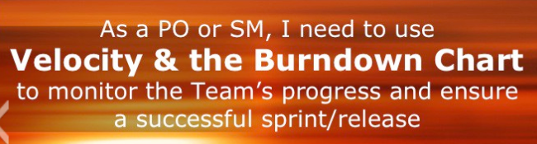

1. **Increment?**

The Increment is the sum of all the Product Backlog items completed during a Sprint and all previous Sprints. At the end of a Sprint, the new Increment must be “Done,” which means it must be in useable condition and meet the Scrum Team’s Definition of “Done.” It must be in useable condition regardless of whether the Product Owner decides to actually release it. **The amount of software you developed till date**.

1. **Scrum Artifacts?**

Product Backlog, Sprint Backlog and Increment



1. **Transparency?**

Significant aspects of the process must be visible to those responsible for the outcome.

1. **Inspection?**

Scrum users must frequently inspect Scrum artifacts and progress toward a goal to detect undesirable variances.

1. **Adapt?**

If an inspector determines that one or more aspects of a process deviate outside acceptable limits, and that the resulting product will be unacceptable, the process or the material being processed must be adjusted. An adjustment must be made as soon as possible to minimize further deviation.

1. **Team Backlog?**

Prioritized list of briefly-described features, user stories, and defects that need to be completed.

1. **Relative Sizing?**

Story points are the common unit of measure for Agile Teams that practice Relative Sizing. The most common scale used for story points is the Fibonacci sequence (1,2,3,5,8,13…)

1. **Program Increment (PI):**

A Program Increment (PI) is a timebox during which an Agile Release Train (ART) delivers incremental value in the form of working, tested software and systems. PIs are typically 8 – 12 weeks long. The most common pattern for a PI is four development Iterations, followed by one Innovation and Planning (IP) Iteration. A Program Increment is to an ART (or Solution Train), as an ‘Iteration is to the Agile Team.‘ It’s a fixed timebox for building and validating a full system increment, demonstrating value, and getting fast feedback. Each PI uses cadence and synchronization to: Facilitate planning Limit Work in Process (WIP) Summarize newsworthy value for feedback Assure consistent, Program Level retrospectives

1. WSJF – Weighted Shortest Job First, is a prioritization model used to sequence jobs (Features, Epics, Capabilities) to produce maximum economic benefit. WSJF is estimated as the Cost Of Delay (COD) is divided by job size.
2. MVP – Minimum Viable Product is a product which has just bare minimum required feature which can be demonstrated to the stakeholders and is eligible to be shipped to production.
3. Essential SAFe – **The art of maximizing the amount of work not done’ is essential**. The Essential SAFe configuration is the most basic configuration of SAFe. It provides a starting point for implementing SAFe and describes the most critical elements needed to realize the majority of the framework’s benefits.  
   Ten essential elements are below:

Lean-Agile Principles

Real Agile Teams and Trains

Cadence and Synchronization

PI Planning

DevOps and Releasability

System Demo

Inspect and Adapt

IP Iteration

Architectural Runway

Lean-Agile Leadership

1. **Estimation Techniques?**

## 1. Planning Poker

All participants use numbered playing cards and estimate the items. Voting is done anonymous and discussion is raised when there are large differences. Voting is repeated till the whole team reached agreement about the accurate estimation. Planning poker works well when you have to estimate a relative small number of items (max 10) in a small team (5-8 people). Tip: try to keep the voting between affordable numbers.  Maximize the highest card to 13 points. [More on planning poker via this link.](https://www.mountaingoatsoftware.com/agile/planning-poker)

## 2. T-Shirt Sizes

This is a perfect technique for estimating a large backlog of relative large items. Especially when you have several concurrent scrum teams working on the same product. Items are estimated into t-shirt sizes: XS, S, M, L, XL. The decision about the size is based on an open and mutual collaborative discussion. This method is an informal and quick way to get an rough feeling about the total size of your backlog. [More about T-shirt size estimation is here.](http://getskillsblogs.com/agile-estimation-with-t-shirt-sizes/)

## 3. Dot Voting

When you are faced with a relative small set of items and in need of a super simple and effective technique to estimate you can use Dot Voting. This method has originated form decision making and you can use it for estimating. Each person gets a small number of small stickers and can choose to vote for the individual items. The more dots is an indicator of a bigger size. Works well in both small and large group. You have to limit the number of estimated items. [More on dot voting here.](http://www.informit.com/articles/article.aspx?p=2117898&seqNum=3)

## 4. The Bucket System

Much faster than planning poker is the Bucket System. This system is a good alternative when estimating a large number of items with a large group of participants. Create several buckets in the sequence of planning poker. The group estimates the items by placing them in these “buckets”. Buckets are usually different sheets of brown paper where you can place the sticky note with the item. But you can also use actual baskets to limit discussion about already processed items. [More on the bucket method here.](http://www.agileadvice.com/2013/07/30/referenceinformation/agile-estimation-with-the-bucket-system/)

## 5. Large/Uncertain/Small

A very fast method of rough estimating is the Large/Uncertain/Small method. The team is being asked to place the items in one of these categories. The first step is to categorize the obvious items in the two extreme categories. Next the group can discuss the more complex items. This is actually a simplification of the bucket system. The system is especially good to use in smaller groups with comparable items. Next you can assign sizes to these 3 categories.

## 6. Affinity Mapping

## This method is based on finding similarities in the estimated items. The team is asked to group them together. Best way is to execute this is a visual way and order them form small groups to large. It works best with a small group of people and a relative small number of items. You can assign estimation numbers to the different groups. [More information about Affinity Mapping.](http://www.gettingagile.com/2008/07/04/affinity-estimating-a-how-to/)

## 7. Ordering method This is an exercise where you get an accurate image on the relative size of items. This works best in a small group of expert. All items are placed in random order on a scale label ranging from low to high. Every participant is being asked to move one item on the scale. Each move is just one spot lower or one spot higher or pass the turn. This continues till no team member want to move items and passes their turn. The ordering protocol is a method of getting fine grained size estimates. Works best with a relative small group of people and a large number of items.

1. **Backlog Refinement?**

During backlog refinement, Product Owner works with agile team to additionally refine each user story and break down larger stories into smaller ones.

Backlog refinement metric: whether my team is having proper backlog work or not? this is available at OSAM reporting hub.

In backlog refinement: we will rank and review the US and give points.

Backlog score: Average velocity/no.of story points available in PB

|  |
| --- |
|  |

|  |
| --- |
|  |

**Sprint Planning Meeting**

The work to be performed in the Sprint is planned at the Sprint Planning Meeting. This plan is created by the collaborative work of the entire Scrum Team.

|  |
| --- |
|  |

|  |
| --- |
|  |

Sprint Planning happens on the first day of the Sprint, facilitated by Scrum Master The entire Agile Team meets to plan the Sprint Scrum Master ensures the Product Owner and Development Team:

•Discuss the goal and context of the Sprint

•Review the prioritized user stories in the Team Backlog Scrum Master ensures the Development Team:

•Pulls stories from the Team Backlog into the Sprint Backlog in the order of priority

•Ensure stories meet DoR before pulling them into the Sprint

•Calculate and consider its velocity when pulling stories into the Sprint

•Consider its capacity when committing to the Sprint (PTO?)

•Creates and estimates tasks for each story in the Sprint Backlog

•Encourage teams to leave the assigned to field blank until work starts on the story. This encourages swarming and a low WIP throughout the sprint. Development Team commits to the Sprint’s deliverables Product Owner agrees to let the team focus on these commitments so that they can deliver on the highest priority work.

|  |
| --- |
|  |

**Daily Standup**

|  |
| --- |
|  |

|  |
| --- |
|  |

|  |
| --- |
|  |



Remember the purpose of stand-up. **The purpose is to get a team goal for the day, and work**

**together to figure out how they’re going to accomplish it.**

|  |
| --- |
|  |

The Sprint Backlog is the subset of the Team Backlog that the team has pulled into the current sprint and committed to delivering. Stories should be small enough to be completed within a sprint; tasks should be small enough to be completed within a day (<8hours).

You can also use the Sprint Status dashboard in Agile Central

* Reports > Dashboard – Sprint Status (S)

**Sprint Review:**

Typical agenda:

* Agile Product Owner explains what user stories have been “done” and which have not
* The team demos working software to the stakeholders
* Stakeholders ask questions and provide feedback
* Team discusses any key events or problems that occurred during the Sprint
* Agile Product Owner shares plans for upcoming work
* All participants give feedback on the backlog

|  |
| --- |
|  |

|  |
| --- |
|  |

A Sprint Review is held at the end of the Sprint to inspect the Increment and adapt the Product Backlog if needed. During the Sprint Review, the Scrum Team and stakeholders collaborate about what was done in the Sprint. Based on that and any changes to the Product Backlog during the Sprint, attendees collaborate on the next things that could be done to optimize value.

This is a four-hour time-boxed meeting for one-month Sprints. For shorter Sprints, the event is usually shorter. The Scrum Master ensures that the event takes place and that attendants understand its purpose. The Scrum Master teaches all to keep it within the time-box.

**Sprint Retrospective:**

|  |
| --- |
|  |

|  |
| --- |
|  |

* Inspect how the last Sprint went with regards to people, process, and tools
* Identify and order the major items that went well and potential improvements
* Create a plan for implementing improvements to the way the Agile Team does its work Find a way to track theImprovement ideas you come up with.
* One great way to do this is to put the action items right into the Sprint Backlog.

|  |
| --- |
|  |

|  |
| --- |
|  |

|  |
| --- |
|  |

|  |
| --- |
|  |

|  |
| --- |
|  |

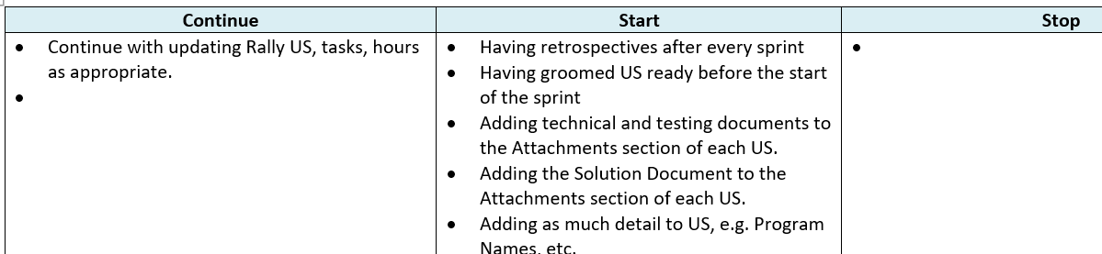

**Servant Leadership:**

A philosophy and set of practices that **enriches the lives of individuals**, builds better organizations and ultimately creates a more just and caring world.

**Build projects around motivated individuals. Give them the environment and support they need and trust them to get the job done.**

|  |
| --- |
|  |

**Higher engagement** – a democratic form of leadership can sometimes cause opposing points of view to be lost or distorted to fit the needs of the group. The servant leadership mindset serves each individual member of the group, preventing alienation among employees and inviting engagement from each person in the group.

**More trust** – As you have more engagement, then managers make decisions with a moral standing that favors the employees. The needs of the staff become of primary importance. This strong consideration for the needs of the employees develops naturally into a strong sense of loyalty from the employee to the company.

**Stronger relationships** – Instead of an autocratic management style, all opinions and inputs matter with servant leadership. A greater sense of teamwork is brought forth into being when managers use a servant leadership mindset to get employees involved in decision making.

**Increased innovation** – When more people are involved and everyone’s opinion matter, then you have a wider variety of solutions to issues and greater involvement. This naturally leads to increased innovation.

**Increased productivity** – Because strong positive feelings evolve between management and their employees, a higher sense of morale and job satisfaction emerge, which naturally leads to increased workplace productivity.

**10 characteristics of Servant Leadership**

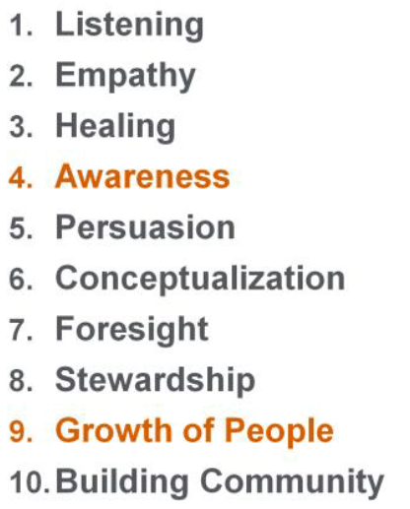 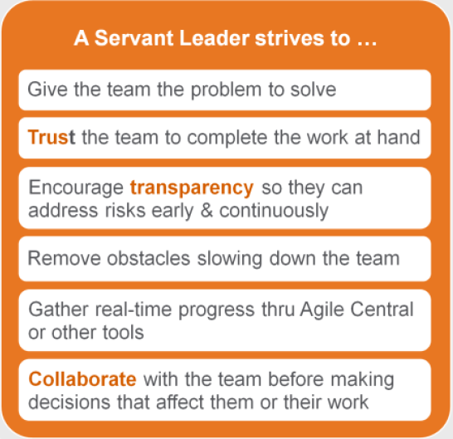

**How do Servant Leaders Empower Others**

|  |
| --- |
|  |

|  |
| --- |
|  |

1. SCRUMBAN: For Matured team, we can have a Kanban flow board created and having section like "Do, Dev, Dev In Progress, Completed'. Events are: Backlog Refinement, Daily Scrum call and Sprint Review
2. How do you plan ‘Releases’ and with whom?

Ans: Will do in Rally along with PO before starting of the project.  Very high-level **plan** for multiple Sprints (e.g. 3 to 12 iteration) is created during the **Release planning**. It is a guideline that reflects expectations about which features will be implemented and when they are completed. ... A prioritized and estimated Scrum Product Backlog.

**To create a successful product release plan, below are the basic steps.**

* Step 1: Define your vision.
* Step 2: Rank the product backlog.
* Step 3: Hold a release planning meeting.
* Step 4: Finalize and share product release calendar.

1. Explain what is importance of SM to PO, Organization and Team?

Ans:

1. How do you go with release milestones?

Ans:

1. How do you resolve team conflicts right away?
2. What kind of metrics you give to management at the sprint end? Planning and execution
3. Scaled Feature?
4. What is your plan to get green line on TTV TTB ?
5. Which metrics affects when we keep updating sprint backlog? (Planning and Execution)
6. What is your plan to avoid keep adding/removing US’s in sprint?
7. As a SM, how do you handle if PO comes up with one feature middle/last of the sprint?
8. What are the best practices or plans you have if you get new team?
9. Enablers: Enablers are everywhere on big picture like Enabler Epics, Enabler Capabilities, Enabler Features, and Enabler Stories. Enablers could be in the form of technical, architectural or infrastructure.

Legt:

1. Do you use SAFe or ?
2. What is your role at planning?
3. What is the best thing you brought from sprint retrospect? Ans: Improving our efficiencies and effectiveness
4. What is the difference between scrum and kanban?
5. What is servent leadership style and how do you handle 1-2 resources in your team?
6. How do you work with your PO/PM apart from daily meetings?

Pega Systems:

1. What is accountability of SM?
2. Why do companies hire SM’s?
3. Why don’t we consider backlog refinement metric as scrum ceromony though it is very imp?

What others are missing in your obsence.

Rolling wave planning can be help to resolve the QA lag.

1. How do you coach a brand new team?
2. How do you go to PI meeting with a brand new team?

**Ans:** Have proper PI pre-planning meeting with team and finish capacity planning, grooming, refining and all make sure team is ‘get ready’ to the meeting.

1. If senior resource is saying he want to finish task asap and don’t want to debate or listen to junior resource. How do you coach them?

**Ans:** Have a discussion with senior resource and tell him about shadow work support from junior resource, so that he can take some big user story or task.

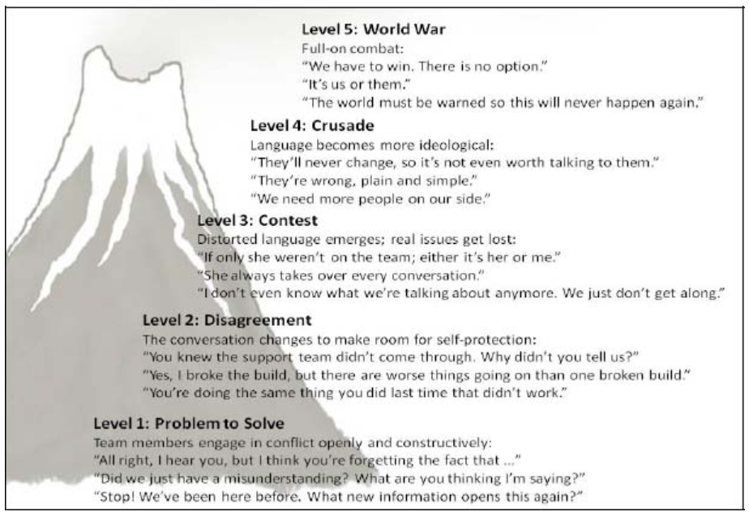

What are tools you use for scrum or SAFe ceremonies?

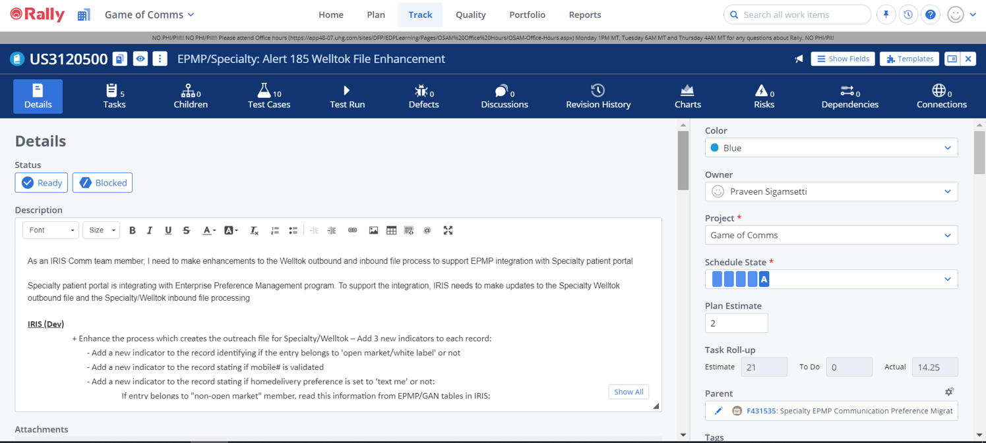

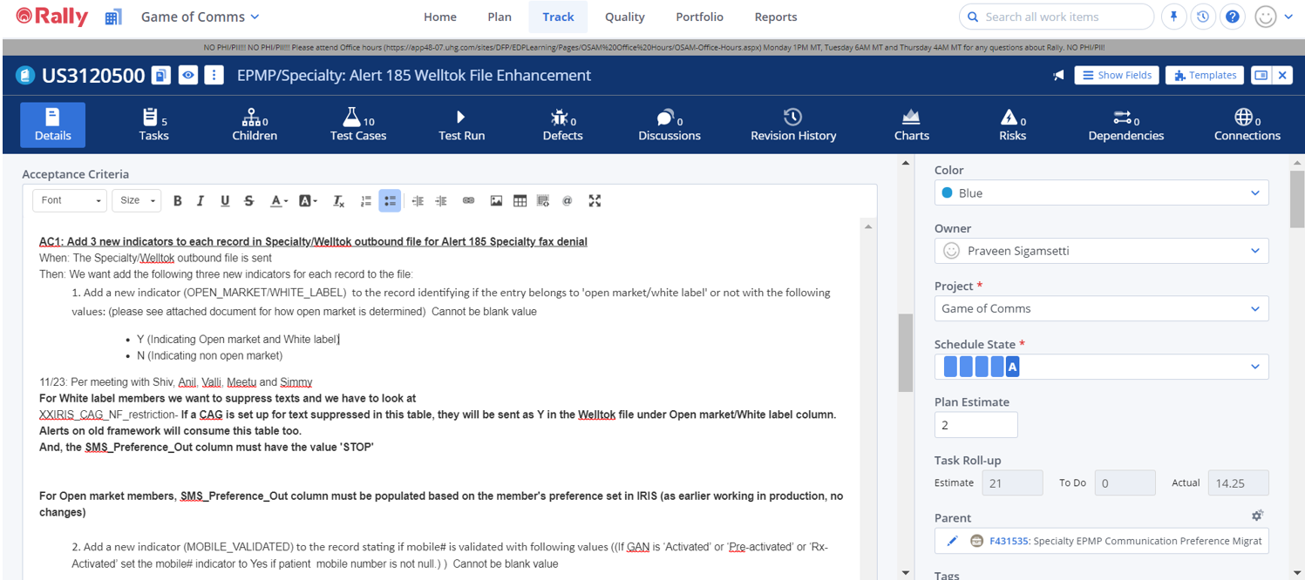

TTV and TTB

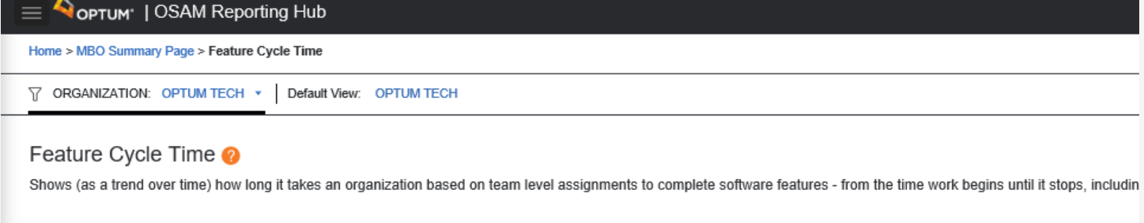

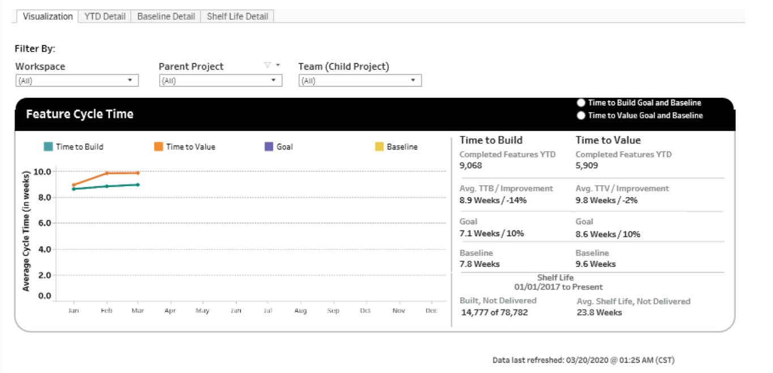

**Productivity:** How do you measure productivity, any formula? And how do you export it to excel sheet from tool?

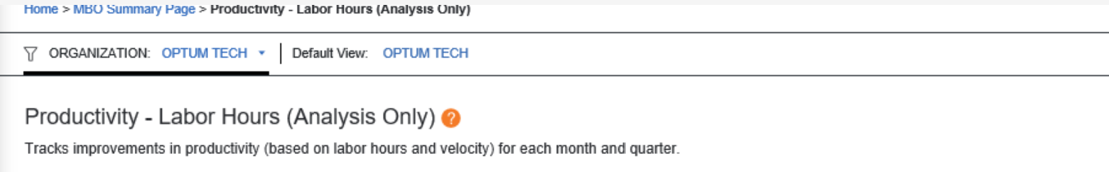

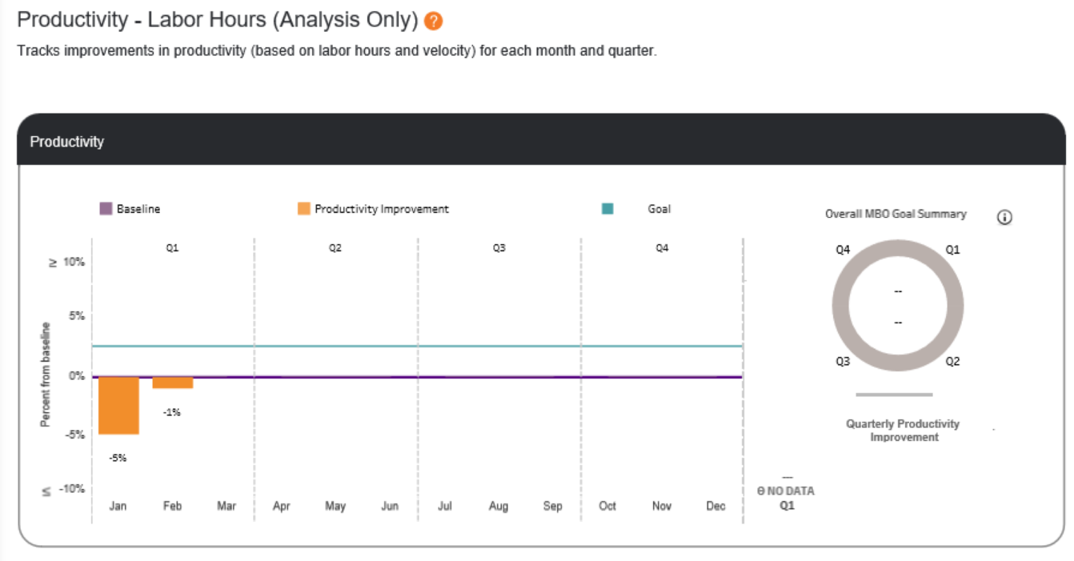

Quality First

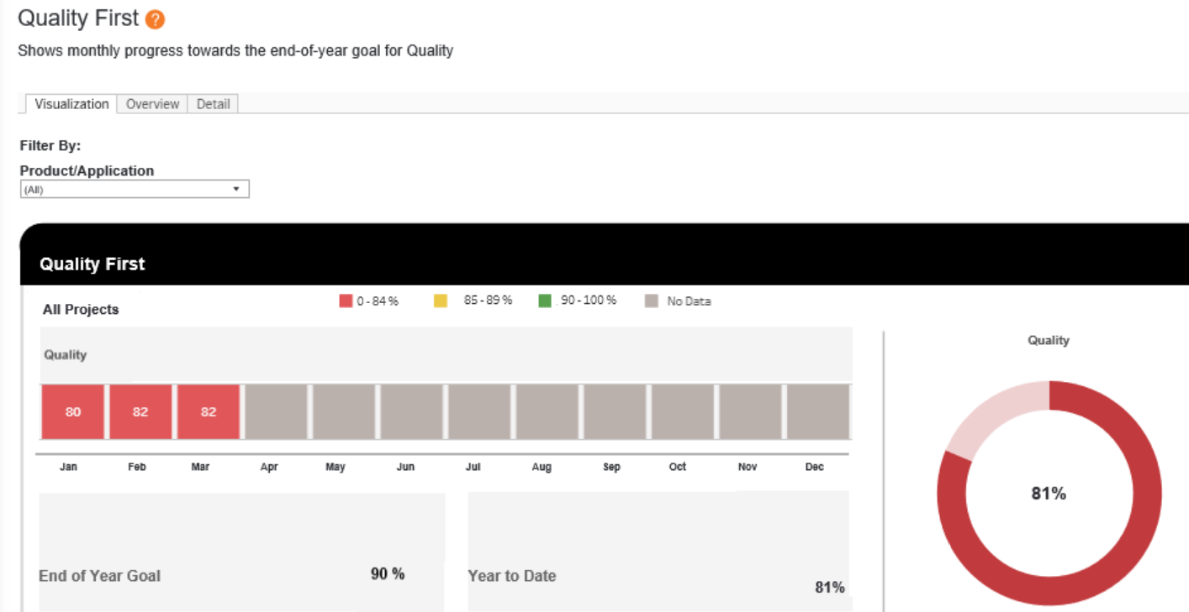

1. What is the diffrence between project manager and scrum mater?

A Scrum Master is a coach and facilitator. A project manager helps manage the project timeline, resources, and scope in order to meet business requirements. A Scrum Master, however, helps ensure the scrum team is successful. A project manager helps ensure that multiple projects within an organization are successful and meeting the business needs while a Scrum Master is generally focused specifically on one project team.

### **Project Manager:**

* Manages the budget
* Reports to business leadership on project progress
* Focuses on process
* Allocates tasks
* Prioritizes features
* Manages risk
* Coordinates with other dependent teams

### **Scrum Master:**

* Serves the team where needed
* Removes blockers or impediments that hinder project progress
* Coaches the product owner
* Monitoring the progress of the sprint
* Helps team estimate and increase velocity
* Promotes continuous communication
* Facilitates sprint planning and other scrum meetings
* Monitors and helps improve team dynamics
* Lends support to whatever part of the project needs assistance at a certain time
* Motivates the team
* Acts as the glue that holds the team together

1. **Definition Of Ready?**

It is a working agreement between the team and product owner on what readiness means. It is an input criteria to plan a story in a sprint. **It is a way for a product owner to indicate an item in the product backlog as ready to work in sprint**. ... Scrum team can refuse to take an item into sprint.

**DOR: Definition Of Ready (Product Backlog)**

|  |
| --- |
|  |

|  |
| --- |
|  |

1. **Definition Of Done?**

Each Scrum Team has its own Definition of Done or consistent acceptance criteria across all User Stories. A Definition of Done drives the quality of work and is used to assess when a User Story has been completed. Done means every task under the User Story has been completed and any work created is attached to the User Story so the Product Owner can review it and make sure it meets his or her expectations

**DOD: Definition of Done** (List of activities that needs to be successfully complete to consider a work product complete).

|  |
| --- |
|  |

|  |
| --- |
|  |

|  |
| --- |
|  |

|  |
| --- |
|  |

**Difference between DOD and Acceptance Criteria?**

Ans: DOD is used to build **things right** (quality). Acceptance Criteria is used to build **right things** (functionality).

Acceptance criteria is for given product backlog item whereas DOD is for entire backlog.

|  |
| --- |
|  |

|  |
| --- |
|  |

**Scrum Burndown Chart**.

A burndown chart is a line chart drawn between "work remaining" and "time". The Scrum Burndown Chart is a visual measurement tool that shows the completed work per day against the projected rate of completion for the current project release. Its purpose is to enable that the project is on the track to deliver the expected solution within the desired schedule.

**X Axis:**  
The X axis of the chart always indicates time (usually in days).

**Y Axis:**   
The y axis represents the remaining work to be done in the sprint. This may be represented by either Tasks Remaining (in # of tasks) or Remaining Effort (in Story Points/Hours).

X Axis: The X axis of the chart always indicates time (usually in days).

Y Axis: The y axis represents the remaining work to be done in the sprint. ...

**Burn Down chart:** X-Axis: Date, Y-Axis: Task To do (Hours)

**Burn Up chart:** X-Axis: Date, Y-Axis: Accepted (Points)

A Burn Up Chart is a tool used to track how much work has been completed and show the total amount of work for a project or iteration. The completed work and total work is shown on the vertical axis in whatever units a project team feels works best, i.e., work-hours, work-days, story points, or any other work unit.  The horizontal access displays time, usually in days, weeks, or iterations (sprints).

The green line is the completed work line and it represents the work your team has completed so far.

The grey line is the total work line and represents the total work you have to do (your project's scope)

**Iteration Cumulative Flow diagram:** X-Axis: Date, Y-Axis (Plan-Estimate). It as grooming, Defined, In-Progress, Completed and Accepted.

**Backlog refinement metric: whether my team is having proper backlog work or not? In backlog refinement: we will rank and review the US and give points. Backlog score: Average velocity/no.of story points available in PB.**

1. **What is Velocity?**

**It measures how much work a team can do in a sprint. Velocity** is a measure of the amount of work a Team can tackle during a single Sprint and is the key metric in Scrum.

**Velocity** is calculated at the end of the Sprint by totaling the Points for all fully completed User Stories. We measure progress in terms of story points.

|  |
| --- |
|  |

|  |
| --- |
|  |

|  |
| --- |
|  |

1. **When you do SoS? Is it a time-boxed ceremony?**

Scrum-of-Scrum (SoS) is an event which is usually conducted with all the Scrum Teams working on a Product to talk about intra-team dependencies, risks, clarifications, etc. The purpose of SoS is for teams to collaborate and talk about dependencies between the teams. SoS is an informal event (not mandatory) which is conducted after the daily scrum meeting – it can also be conducted whenever required (say, twice a week). Couple of responsible/authoritative guys from each team (not SM’s) attends the meeting and discuss their work and answer the questions like –

* Since the last meeting, what is the progress of the team?
* What your team is expected to do or should accomplish, before the next meeting?
* What are the obstacles your team faced while completing the task – dependencies on other teams?
* Were you going to allot any of your work to the following team?

SoS is not a time-boxed event. It’s just an informal event which is conducted during the need.

SoS is not for Scrum Masters; instead it is for the Development Teams to discuss about dependencies.

1. **How do you decide your baseline for estimation?**

Traditional estimation is based on absolute estimation **whereas Agile estimations are based on relative estimation.** We cannot estimate empirical process system using time – start looking at Relativity instead of time (compare with reference feature) Like, how big it is to do this work as compared to some other work for a team instead of a given individual. **Relative sizing is estimating the size of a function or user story based on the size of another one. The reference story should have less complexity, less amount of work, less uncertainty.**

1. **Explain Self-organization vs Self-motivation?**

Self‐organizing teams choose how best to accomplish their work, rather than being directed by others outside the team. Self‐organizing teams are proven to be hyper productive – best way to solve complex problems. A self-organizing team knows how to do their work. No one from outside the team is allowed to tell them how to do the work. Scrum Master should reduce external dependencies to make team self-organizing. Individual team members take accountability for their own workload even though they shift work among themselves based on need and best fit, and most importantly take responsibility for team effectiveness. The team decides:

* + - What backlog items to work on in a given sprint?
    - How to implement the items with regards to technology and design etc.?
    - Work allocation and capacity planning.

A good Agile leader should let the team self-manage, within a certain set of core principles. Hence, it is the team which manages the project

Note:

* Great power comes with great responsibility
* Adults learn by doing things, not by listening
* Scrum teams are long-live ==> high performance teams.

Teams that stay **true** to the spirit of **Agile** are self-organizing

|  |
| --- |
|  |

**C**ontinuation **I**ntegration: is a set of engineering practices that merges all codes into main line and requires integration testing multiple times per day.

**C**ontinuation **D**elivery: a set of practices in engineering divided to help developers build, test and release software faster and more frequently.

**T**est **D**riven/First **D**evelopment: We write test cases first and writes code to pass on them then we refactor. Selenium

**B**ehavioral **D**riven **D**evelopment: Testing the actual behavior of the system from the end users perspective. We write acceptance test cases in the form of examples using Given When Then.

1. **What is the difference between Kanban and Scrum?**

**Kanban is flow based/optimizes flow and reduce wastes like multi-tasking.**

|  |  |
| --- | --- |
| **Scrum** | **Kanban** |
| Scrum suits for Development projects | Kanban suits for Maintenance/Support projects |
| Scrum is uncertain – so cross-functional teams/skill are mandatory | Kanban is certain – so cross-functional skills are NOT mandatory |
| Time-boxed iterations (Sprint) are prescribed | Can be event-driven instead of time boxed |
| Team commits to a specific amount of work for this iteration | Commitment optional |
| Use VELOCITY as default metric for planning and process improvement | Uses LEAD-TIME as default metric for planning and process improvement (**Lead time** is the period between a new task's appearance in your workflow and its final departure from the system.) |
| Items broken down, so they can be completed within one sprint | No item size is prescribed |
| Estimation prescribed | Estimation optional |
| Prescribes 3 Roles (SM/PO/Team) | Doesn’t prescribe any Roles |
| A Sprint backlog is owned by only one team | A Kanban board may be shared by multiple teams / individuals |
| WIP limited indirectly (per sprint) | WIP limited directly (per workflow state) |
| Has Sprint Planning, Daily Scrum, Retrospective, etc. | No Sprint, No Sprint Planning, No Retrospective, Only Daily Scrum. |
| Prescribes prioritized Product backlog | Prioritization is optional |
| A Scrum board is rest between each sprint | A Kanban board is persistent |
| Cannot add items to ongoing iteration | Can add items whenever capacity is available |
| Burndown chart prescribed | No item diagram is prescribed |

**Anti-Patterns and challenges:**

**At Daily Scrum:** Team hijacks stand up meeting to discuss new req, to refine user stories or detailed discussion.

Overcrowded, Line managers joins to gather performance data which should not. Late attendees or skipping wantedly

**At PBR:** Missing acceptance criteria, not following INVEST model, Oversized, part time PO, Copy-Paste PO.

No time for refinement or too much refinement.

**At Sprint Planning:** Unfinished US’s are spill over into new sprint w/o discussion, Last minute changes, over commitment

**At Sprint Review:** Selfish PO who mentions about his/her accomplishment to business.

**At Retro:** No frequent Retro, no accountability, boring of retro format, bullying, no documentation, Managers present

**Challenges:**

**Example1:** Team is with full of skilled people, debating on design or architecture with same level people or Jr level people. Senior people may take it to personal abuse by stating, I’m senior than you, how can you condemn my analysis/design?

**Answer:**

* Take him to 1-0-1 and ask him what is his purpose, team purpose and business purpose. Understand the intent, understand the purpose, explain them to ‘**make them realize**’.
* **Can you do it alone**? Or team together can work on it, **be a good listener** so listen to others view also & comment.
* We **can create opportunities from debates** where team can have different views ideas on same product.
* If person is still not listening and doing it wantedly, then ask him what he wants like any specific role or work.

**Example2:** Both developers and testers are complaining like, developers giving user stories in last minute of sprint, so it is difficult to finish quality testing. Developers says testers are raising unnecessary defects in last minute.

**Answer:** Assign all dev to single US, deploy it, work on next US, so that they can have enough time. **Rolling wave plan**.

Try to build friendly relations with developers, so that they can feel comfortable to share anything with you. Keep your issue reporting style positive, it should not hurt someone’s feelings.

**Example3:** Team is having few unskilled people, they are skipping from work and calls, how did I deal?

**Answer:** Talk to them and ask them what is the problem, provide trainings to them from SME’s, so that they can copeup.

**Example4:** Person is skipping or joining late to the calls. **Ans:** tell him his importance & what team is missing in absence.

Both Dev team and PO feels these meetings are waste of time. Ans: Explain them the power of scrum. If we make them understand about scrum, then it will give results in sometime.

1. Your team's performance is constantly not meeting commitments and its velocity is very volatile. What are possible reasons for that? And how would you address those issues? – Below are few examples
   1. Scope changes – Can be discussed with dev team and address with PO – Inspect and adapt
   2. Unclear requirements – Need to improve PB refinement process
   3. Unplanned PTO’s – Sprint planning to be improved considering capacity Vs load
   4. Lack of cross functional team – Talk to PO/Dev team and have suitable practitioners into the team

2. How can you as a Scrum Master contribute to the sprint planning in a way that the team is really working on the most valuable user stories?

* 1. Make sure PB is refined,
  2. Enable PO and dev team to discuss on MVP’s
  3. DOD is defined

3. What are the common anti-patterns we observe most often in Daily scrums and how do you handle them as a Scrum master?

* 1. Not keen in attending daily scrum
  2. Not calling out any blockers
  3. Transparency is missing what we have done and what we are going to forecast for next 24hrs

As a SM, talk to team member, and coach the importance one of the pillars Transparency.

Also, values of scrum - Courage, Commitment, Focus, Respect, and Openness.

1. What are the main reasons why we call “Backlog refinement” as an activity rather than ceremony?
   1. Backlog refinement is helps in effective sprint planning and is continuous activity happening though the product life cycle and is not a time boxed. Hence, is not ceremony
2. As a Scrum Master, how do you identify key stakeholders and what approach do you take to manage them?
   1. Customers, Users, PO, Purchasers and team funding the product development
   2. Daily communication, understand need and expectation from them
   3. Planning and implementing various tasks to engage with them
   4. Usually a PO represents stake holder community
3. The Agile Manifesto says, "People over processes." Isn't the Scrum Master – a role to enforce "the process" – therefore a contradiction?
   1. Process to be followed in scrum is minimal since people make product.
4. How do you deal with a product owner that assigns user stories or tasks to individual team members?
   1. Coach the PO on how is it going to impact the sprint goal. Talk to PO and understand the criticality of the user story / task and plan accordingly.
5. How do you handle team members that "lead" standups, turning them into a reporting session for them?
   1. Coach them the importance of transparency about impediments and forecast for next 24hrs.
6. What does “Being Agile” really mean to you and describe any real time experience associated with it?
   1. As an example during sprint reviews/retrospection, feedback / improvements are shared. Team exhibits various values of agile like courage, respect, and openness.
7. What is the driving force for you to become a Scrum Master and what did you like most about the role?
   1. This is an opportunity to coordinate with various stake holders, PO, and Dev team and deliver a quality product by coaching the team on Agile Values and principles. As a part of this role, SM coaches and empower the scrum team and enable them to improve their cross functional skills
8. Were you part of resolving any “Conflict” at work and describe any real time scenario associated with it?
   1. Defect’s creation
   2. During Sprint Reviews
9. As a Scrum Master, how do you manage the situation of continuously managing scope at work?
   1. Make sure high business valued stories addressed first by discussing with PO
   2. Capacity Vs Load planning
10. Why should we prefer the Relative estimation techniques over traditional time-based estimation techniques?
    1. Relative estimation is done based on T-shirt confined to S,M,L, XL,XXL. However, when it comes to absolute, team members give different values.
11. How can we handle the challenges associated working with the team members distributed across locations?
    1. Have regular connects
    2. Plan for regular gathering by location or making team to travel to other places so that team understands each others
    3. Team games
12. What will you do as a Scrum Master in making the Retrospection meetings effective and actionable?
    1. Appreciate the team for the good work
    2. What improvements have been successfully made from last retrospection
    3. Encourage teams to talk, appreciate others
    4. Gather the data and generate insights
    5. For any issue, identify the root cause and action plan
    6. Change the retrospect format if required (DAKI, Speed Boat, What went well, Start/Stop/Continue)
13. **Why do we use SAFe over scrum?**

With Scrum, we can know which features/epics are getting implemented in next 2-4 sprints.

However, with SAFe we can know next 2-3 releases. Also, in addition SAFe brings values like

In-Built quality, Alignment, Program execution apart from Transparency

1. **Retrospection example**

Dev team did test, and quality was much appreciated. However, ADA was missed, and this was taken

as feedback and converted into actionable items and implemented in next sprint

1. **Servant Leadership example**

Dev team was having issues coming with a strategy for data loading. As a SM, I probed questions

that enabled the lead to come up with strategy

1. **If initiative is failed, what kind of actions you have taken**

Automation testing was planned and strategized. However, project team could not find automation

experts and as a result team was off-track for about 2-3 weeks. As a SM, I consulted Project

management team and HR team to hire contractors and got the task complete

1. **Of all ceremonies which ceremony you like more and why**

All ceremonies I like. However, review and retrospection take higher rank since that is one of

the windows where incremented product is inspected by PO, stake holders, and SM. Dev team

takes acknowledges (adapts) the feedback, respects them and work on the feedback.

This continuous feedback the team to deliver high value business increments with good quality

1. **Apart from regular scrum activities, what all you do in a day**

* Talk to PO team, Dev on impediments. Track it to closure
* Work with other SM’s at organization level to understand if they found any kind of impediments/any situations, how did they resolve them
* Train/coach practitioners on Agile values and practices

1. **With the pandemic, if one of your team members is sick and is on PTO. How would manage the situation**

Well-being is very important. As a SM, I would talk to rest of the team members and ask what

we can do in the situations and seek solution from them

1. **Is it mandatory for a SM to have technical skills?**

That is not mandatory. However, it is good to have. During any discussions with SM will have what

is being discussed if he has technical aspect.

1. **When team is under committing, what is the probable cause and as a SM what steps do you take?**

Estimates are not provided properly, and this happens due to improper PB refinement.

Hence as a SM, enable to team to discuss and ask more questions to PO during PB refinement

1. **When there is a change in architecture, as a SM what have you done?**

Have 2 branches created, on one branch continue with ongoing sprint activities and in another

branch make changes and test it simultaneously. After testing is complete, merge both the

branches and do regression testing

1. **When there are conflicts within the team, how did you handle them?**

Architectural/solution approach suggested were different. Hence, SM can facilitate meeting and

ask questions about the approach and details. This is constructive disagreement

1. **What made you to take-up this role**

This gives me an opportunity to work with different team members, also connects dev team

with PO and stake holders, coach, mentor and be servant leader to the team

1. **What are the strengths and weaknesses you have? How do you overcome your weaknesses?**

Tell strengths and convert them to weakness

1. **How do you handle a team member who does not follow scrum?**

Coach him on the scrum values, importance of following it and how it helps.

In spite of repeated coaching, if he is not still following, we can escalate to reporting manager

1. **What is the most irritating behavior you experienced as a SM?**

When people do not listen after continuous coaching and impacting product delivery

1. **How do you handle PO with arrogant behavior?**

Coach the PO – importance of scrum values and how impacts team’s performance.

1. **When there are multiple scrum teams, how do you handle**

SOS, No conflicts with daily scrum meeting

1. **How do ensure that user story is written properly**

INVEST principle

1. **What would you do if team members are not talking in retrospection?**

Ask them powerful questions about certain scenarios, like how is collaboration, planning etc.

also coach the importance of retrospection

1. **Metrics in Scrum**

* Agile maturity assessment
* Quality metrics like defect leakage
* Time to Market

1. **How do you deal with scope creep?**

* Talk to PO if added scope is high valued business items
* Talk about Load Vs Capacity
* Adjust the sprint backlog

1. **How do you measure your success?**

* How well team members are following scrum values
* Coaching team
* Acting as Servant Leader

**23. Agile Metrics?**

Agile Maturity Assessment, Defect Leakage, Feature Value Index, Time to Market

**24. What do you do if team is under committing?**

- Plan Product Backlog Refinement in an effective way.

- Encourage the dev team to ask questions, and get them clarified from PO, Acceptance Criteria defined clearly,

INVEST principle is applied for each PBI, Technical dependencies are resolved.

**25. How do you manage the cross located teams during PB refinement sessions?**

- Have meetings that suits everyone

- Have a PO at offshore as well so that dev team can have questions clarified.

- Change in shift timings

**26. What are the reasons for change in velocity?**

-New team members joining

-Experienced leaving the team

-Addressing any ad-hoc work items like PBI’s, Bugs.

-Unplanned PTO’s, Any emergencies, Technical Dependencies

**27. Release Burn Down chart?**

Progress on a Scrum project can be tracked by means of a **release burndown chart**. ... The horizontal axis of the sprint **burndown chart shows** the sprints; the vertical axis **shows** the amount of work remaining at the start of each sprint. **The scrum master** updates the release burndown chart with actual progress made at the end of each sprint before the next sprint starts. There are 2 people on the team. Each person producing 6 hours of work equal to 6*5 hours = 30 hours weekly per person.

**28. User Stories Horizontal and Vertical Slicing?**

Vertical slice is a shorthand for “**a work item that delivers a valuable change in system behavior such** that you'll probably have to touch multiple architectural layers to implement the change.” When you call the slice “done,” the system is observably more valuable to a user.

1. Split by capabilities offered. This is the most obvious way to split a large feature.
2. Split by user roles. ...
3. Split by user personas. ...
4. Split by target device. ...
5. The first story. ...
6. Zero/one/many to the rescue. ...
7. The first story—revised. ...
8. The second story

29. Test Pyramid?

Testing Pyramid is **a framework that can help both developers and QAs create high-quality software**. It reduces the time required for developers to identify if a change they introduced breaks the code. It can also be helpful in building a more reliable test suite.

The agile test automation pyramid is **a graphical strategy guide for implementing automated software testing**. The model splits types of testing into three layers based on the return on investment (ROI) offered by automating that particular type. ... Unit tests involve testing small units of code.

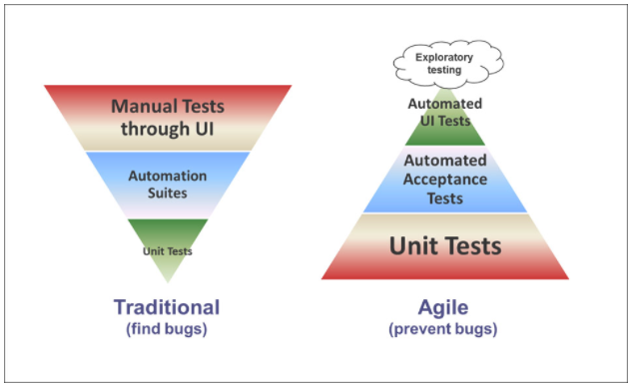

Strategic themes -> Epics -> Capability -> Features -> User Stories -> Tasks

SM’s role at PI planning: Concentrate on SOS meetings. Are we load more work (capacity)?, team is properly estimating or not?, team is identifying dependencies or not?, tag your dependency US to other teams.

Reprioritization and proper capacity planning is key for SM. Get ready with pre planning and cover capacity planning, planned velocity. Capacity planning, Feature allocated to the team. Break out sessions, slice features into user stories. Next we address dependencies, further features next coming sprints.

**SAFe:**

SAFe or the Scaled Agile Framework™ is a series of guidelines and practices designed to help bring agility into larger organizations, across all teams and levels of the business. The framework is geared at improving visibility, alignment, and collaboration and should lead to greater productivity, better results, and faster delivery.

Structured release planning is diff b/w SAFe and Scrum. Team dependency management. Enterprise level many teams can be handled with SAFe.

**SAFe Values:** <https://www.scaledagileframework.com/safe-core-values/>

* 1. Alignment (aligning all teams to a ART)
  2. Transparency (around artifacts)
  3. Built-In-Quality (quality check is within and part of prod)
  4. Program Execution (PI Panning)

**SAFe Principles:** <https://www.scaledagileframework.com/safe-lean-agile-principles/>

* + 1. Take an economic view
    2. Apply systems thinking
    3. Assume Variability; preserve options
    4. Build incrementally with fast, integrated learning cycles
    5. Base milestones on objective evaluation of working systems
    6. Visualize and limit WIP, reduce batch sizes, and manage queue lengths
    7. Apply Cadence, synchronize with cross-domain planning
    8. Unlock the intrinsic motivation of knowledge workers
    9. Decentralize decision-making
    10. Organize around value

**PI:** Program Increment (**PI**) **Planning** is a cadence-based, face-to-face event that serves as the heartbeat of the Agile Release Train (ART), aligning all the teams on the ART to a shared mission and Vision. A Program Increment (PI) is a timebox during which an Agile Release Train (ART) delivers incremental value in the form of working, tested software and systems. Meant for longer s/w products, more teams, longer timeframes. (50-125 people). **8-10**

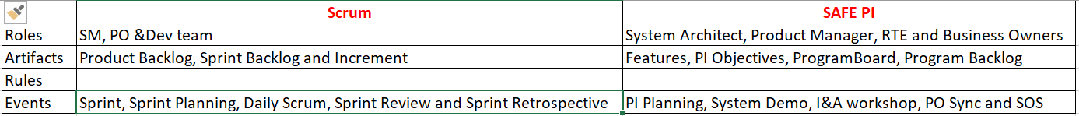

We do PI using with PI planning.org. **PI Metrics:** Program Predictability Measure/PPM, Capability/maturity assessment

Inputs of PI: Program vision, top 10 features

Outcome of PI: Program board, committed objectives with a plan, high level commitments.

Benefits: High bandwidth communication across teams/Train. Build social n/w, Alignment, Identify dependencies, accelerate decision making, foster just right amount of architecture/UX.

PI Objectives: summery of business & technical goals that an agile team/train intends to achieve in the upcoming PI.

Show routing calculations, Navigate autonomously, Parallel park for a delivery, return to the distribution center after delivery, Include traffic data in route planning, recall a delivery, demonstrate real time routing to avoid delays.

Program Board: Two things are shown here. 1) Wen we expect features to complete across the PI in which iteration. 2) Cross Team Dependencies, will use this artifact in SOS executing PI’s to see are we on track.

**PO Sync:** Finalize top 10 features. PMC (Product Management Council) is the term we use in our company. PM facilitates PO sync with PO’s and feedup work for next PI’s also.

**ART Sync:** Both SOS and Po Sync together in a single meeting.

PI Events: **B**usiness Context, **P**roduct Solution/vision, **A**rchitectural Vision/Development Process, **P**lanning Contest/Lunch

**T**eam Breakouts, **D**raft Plan Review, **M**anagement Review&Problem Solving, **P**lanning Adjustments, **T**eam Breakouts,

**F**inal Plan Review/Lunch, **P**rogram Risks, **C**onfident Vote, **P**lanning Rework, **P**lanning Retrospect/Moving forward.

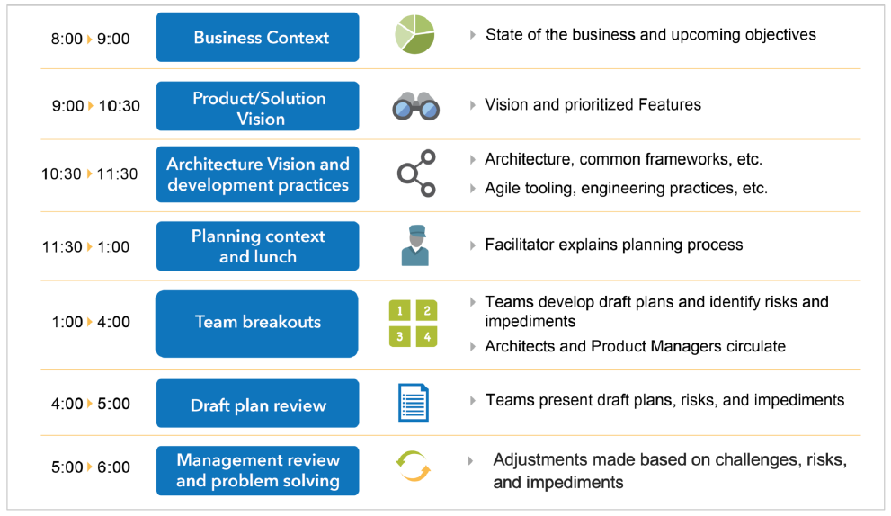

.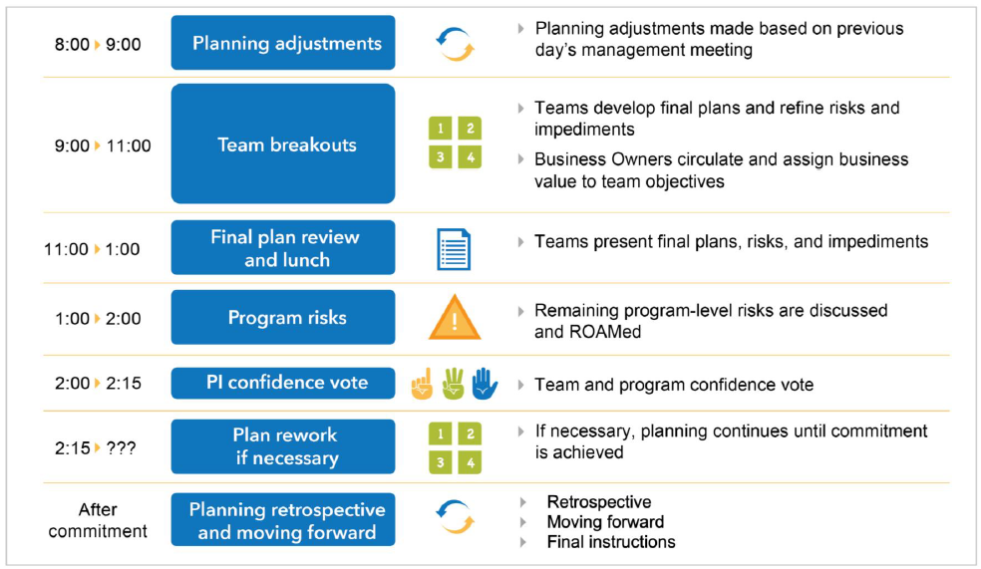

SAFe 4.0 vs 5.0: Organizational Agility and Continuous Learning Culture have been added as two new core competencies, so total 7 competencies in 5.0 earlier was five only in 4.0.

What is predictability and reliability?

**Predictability**: The ability to plan and deliver. Productivity: Getting more done in the same time or with the same resources. Quality: A product free of defects and issues. Stability: The organization can maintain this pace indefinitely. One of the most useful **measures** of **predictability** is scope variance. While velocity will indicate the number of story points delivered, the number of story points missed is rarely captured but directly impacts the team's ability to deliver on their commitments.

**Commitment Reliability**  
Shows the percentage of story points completed against its **commitment** for every sprint. With Trend record among last 6 completed sprints. the difference between Committed Story Points vs. Delivered Story Points over time – you should aim to deliver as close to 100% as possible (no higher, no lower).

What do you do in I&A?

The **Inspect and Adapt** (I&A) is a significant event, held at the end of each Program Increment (PI), where the current state of the Solution is demonstrated and evaluated by the train. Teams then reflect and identify improvement backlog items via a structured, problem-solving workshop.

Iteration review? Lean agile house? SAFe house of lean

How do you define US? SAFe Objectives? PI objectives

If a QA person/s are not available last 3days of sprint and there is some work left, how do you handle?

How do you handle if there is no program vision defined? Diff b/w grooming and refining?

Testing defect process?

Outcomes of sprint review? Ans: Feedback, Sprint goal achieved or not?

If we give 2 new teams (one is fresher or exp), how do you handle?

**For Exp team, ask them how they r working now interms of scrum process, story points n all?**

How do you track your dependencies? Ans: Jira align

If you don’t have Jira align, then? I will use Mero

Your PO is not knowledgeable? How do you handle?

How do you handle/consider risks? (Five Why (It talks about problem), Fish Bone technique (specific root cause))

Risk can be a positive/negative, results can turn into good or bad/benefit or loss. Ex:

**Labels do you use for MOSCOW in Rally?**

We have deadline for 3months and team did good job in first 2 months and last month going wrong, but we should meet client’s deadline (otherwise we have to pay penalty), what do you do as a SM?

How do you make sure your product is quality? On what basis like metrics or -> Andon Cord/built in quality (DOR,DOD)

How do you measure success in SCRUM:

1. If all 5 scrum values are reflecting in team.
2. Sprint Goal **Success**. A Sprint Goal is an optional part of the **scrum** framework. ...
3. Escaped Defects and Defect Density. ...
4. Team Velocity. ...
5. Sprint Burndown. ...
6. Time to Market. ...
7. ROI. ...
8. Capital Redeployment. ...
9. Customer Satisfaction.

KPI: A **Key Performance Indicator** is a measurable value that demonstrates how effectively a company is achieving key business objectives. Organizations use **KPIs** at multiple levels to evaluate their success at reaching targets.

PPM: The **Program Predictability Measure** metrics shows the comparative analysis of actual BV achieved to planned BV. ... The graph is plotted based on the percentage of BV achieved against the planed in the Y-axis and the PI's on the X-axis.

Servant Leader: Listens and support team members in problem identification and decision making. Building projects around motivated individuals.

Feature Taggels: Masking deliverables in production (not visible to users).

Architectural Runway: Existing code, hardware components that technically enables near-term business features.

ART’s system architect facilitates it. Each PI serves as the time to lay down the tracks for what we think we will need in order to achieve our goals in the following PI.

Technical Debt: **When IT teams need to forgot certain development work** – [such as] writing clean code, writing concise documentation, or building clean data sources – to hit a particular business deadline. Technical debt (also known as design debt or code debt, but can be also related to other technical endeavors) is a concept in software development that **reflects the implied cost of additional rework caused by choosing an easy (limited) solution** now instead of using a better approach that would take longer.

Latest changes in Scrum guide? Product Goal, One Team (no sub teams) & one Product focus, Less Prescriptive,

Development Team -> Developers

Roles -> Accountabilities

Self-organize -> Self-manage (team internally decides who does what, when&how)

Introducing “Why” in sprint planning along with What and How. Team discuss “Why is this sprint valuable”

Replacement of term ‘estimate’ with SIZE. Entire scrum team is accountable for creating a valuable, useful increment

Suggested scrum team size of 10 or fewer people (it was 3-9 earlier)

How do you make sure your product is quality? Code reviews, peer code reviews, DOD.

(Ex:**Andon Cord/build in quality in production itself (in DOR & DOD))**

Sprint Planning inputs/outputs? **I/P:** Refined Product Backlog, DOD, Capacity, Velocity, prv sprints Retro action items.

**O/P:** Sprint Backlog and Sprint Goal

Coaching and mentoring: coach them around intent of issue and let them understand same and take it as an opportunity. Explaining the advantage in enabling effective collaboration helps narrow down the issue. Effective facilitation, bringing right people, keeping the intent.

Example of Servant Leadership: I was working with a team fulfilled with good techies. I always encounter people where they get into conflicts w.r.t architecture/design needs. Sometimes they resolve conflict on their own, and many times they need my intervention where I coach them (by asking powerful questions), empower and encourage them. over a time, we observed these healthy conflicts results into opportunities for people to develop and sustain.

**Kanban is flow based/optimizes flow and reduce wastes like multi-tasking.**

**Why should company hire a SM?**

SM is the servant leadership who lays a path towards sustainable development.

DevOps process

**Tracability in user story?**

What have you done to make the team better in terms of culture and Continuous Improvement?

Making artifacts transparent. Leading the team in Inspect and Adapt way. Making everyone accountable towards business outcomes. So living with empiricism is the key things to drive any improvement which leads to a sustained culture. Trust and Respect are more important.

How to improve productivity:

1) Best practices, reusable utilities/componnts. ex: excel sheet

2) Cross trianed so that u can decrease wait time and dependancy

3) Automation also one of the crit

4) unit test automation

DevOps process in your team:

Part of CI process, tools are SVN/Github, Maven

CD Process -> Jenkins (Kubernet, Azure).

User Story: Short description of a small piece of desired functionality written in user’s language.

As a (User Role) I want to (Activity), So That (value)

3 C’s. Card, Conversation (PO&Dev), Confirmation (Acceptance Criteria)

Defect density is the number of defects found in the software product per size of the code. It can be defined as the number of defects per 1,000 lines of code or function points. **Defect Density = Total Number of defects/Total lines of code**.

QA person is not available last 2-3days of sprint and tasks are left over, how do you handle?

Why are you looking out for a change?

How do you make sure you are delivering a quality product?

|  |
| --- |
|  |

Do you take care of release planning and all?

How do you make sure your team is improved in terms of metrics or anything?